
WAREHOUSE MANAGEMENT SYSTEM

USER GUIDE

Introduction

This user guide provide the general basic function of setting up and operating of this warehouse management system

The WMS administrator will provide the User Login ID and Password for granted personnel
to access into the system.

The menu options are order by ascending alphanumeric sequence.

For logging into the system please refer below:-

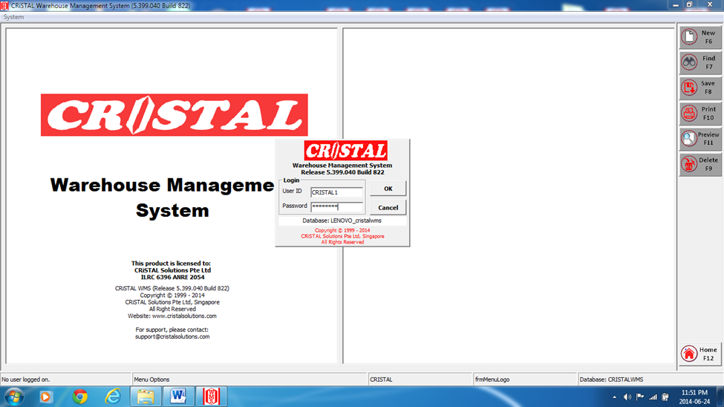

CRISTAL WMS USER GUIDE
Main Menu
2 4 3 7 5 6 1

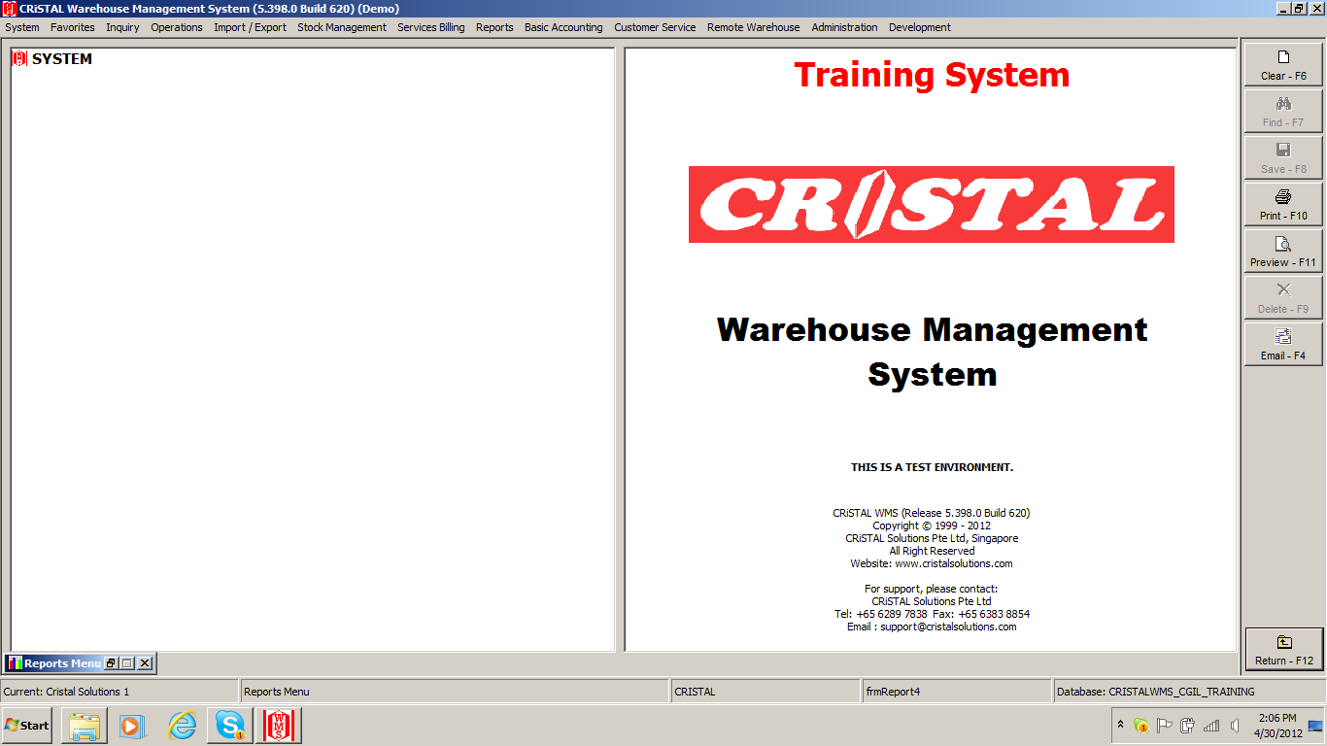

Contents:
- Administration Page 04 - 24
- System Page 25 - 26
- Operations Page 27 - 35
- Inquiry Page 36 - 40
- Stock Management Page 41 - 45
- Reports Page 46 – 48
- Import / Export Page 49 - 51

- ADMINISTRATION
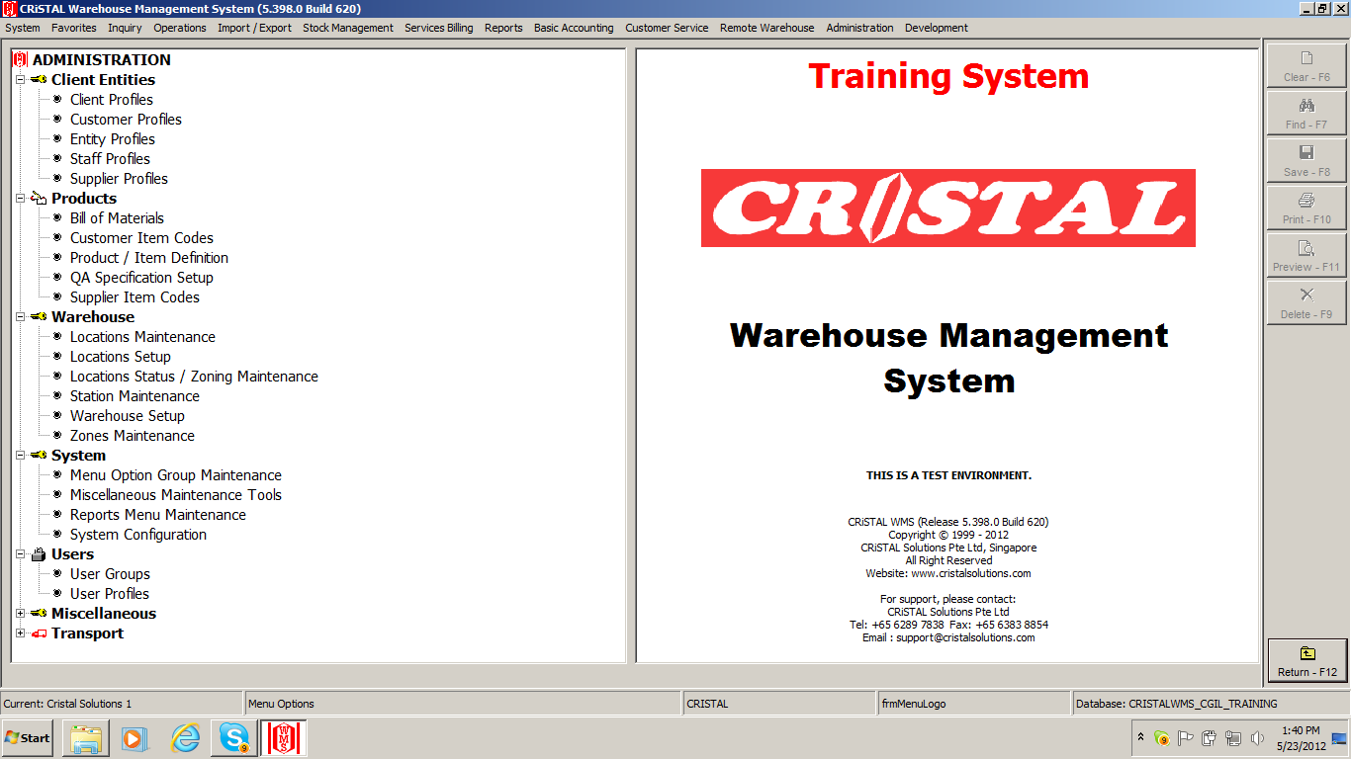
C
A
D
B

Steps for setting up for operation:-
- Warehouse
- Warehouse Setup
- Station Maintenance
- Zones Maintenance
- Location Setup
- Location Maintenance
- Client Entitles
- Client Profiles
- Customer Profiles
- Supplier Profiles
- Users
- User Groups
- User Profiles
- Products
- Product / Item Definition

1 – A) WAREHOUSE
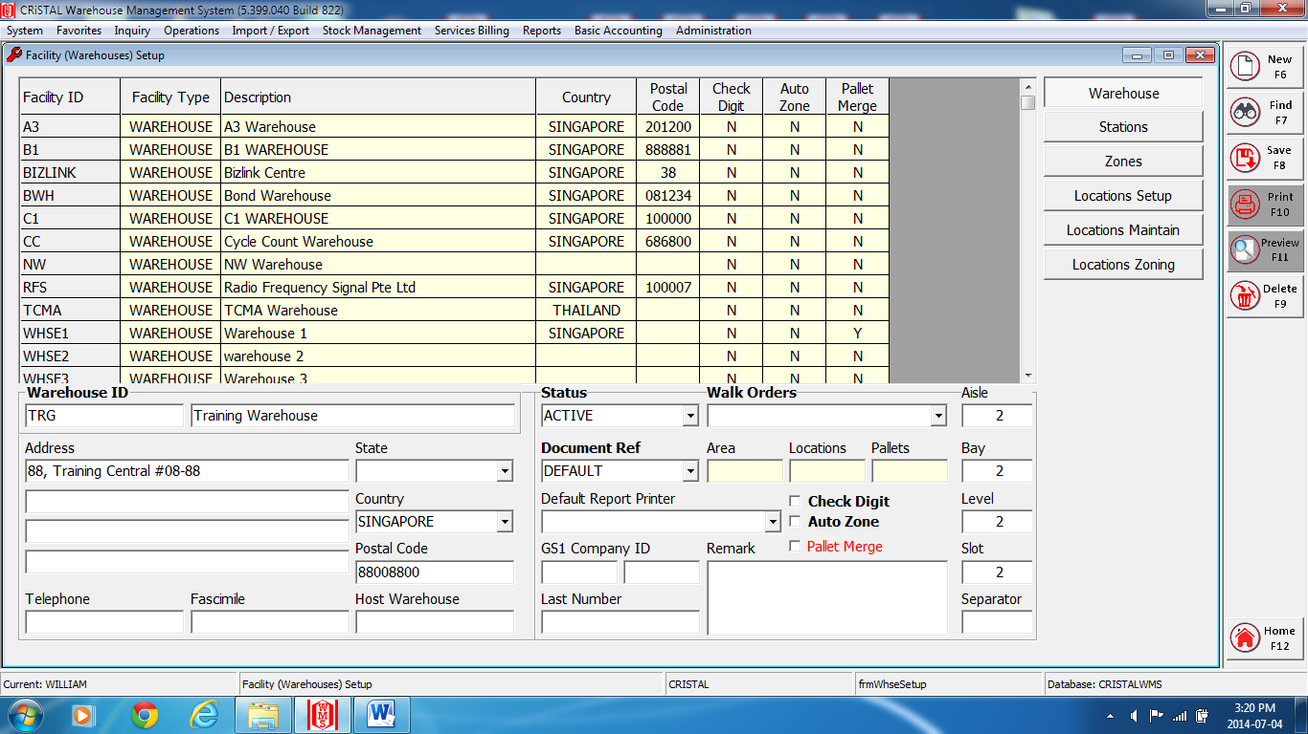 i ) Warehouse Setup

- Enter a Warehouse ID at ‘Facility Code’ field.
- Enter the name of the warehouse at the ‘Name’ field. (Next to the Warehouse ID field)
- Select the prefer document reference series at the ‘Document Ref Series’. Use ‘DEFAULT’ if no preferences.
- Enter the address details at the ‘Address’ field.
- Enter ‘Save’ or ‘F8’ to complete the set-up.
Note*: a message ‘Warehouse data updated’. Enter ‘OK’.
- Close and exit the page.

1– A) WAREHOUSE
ii ) Station Maintenance
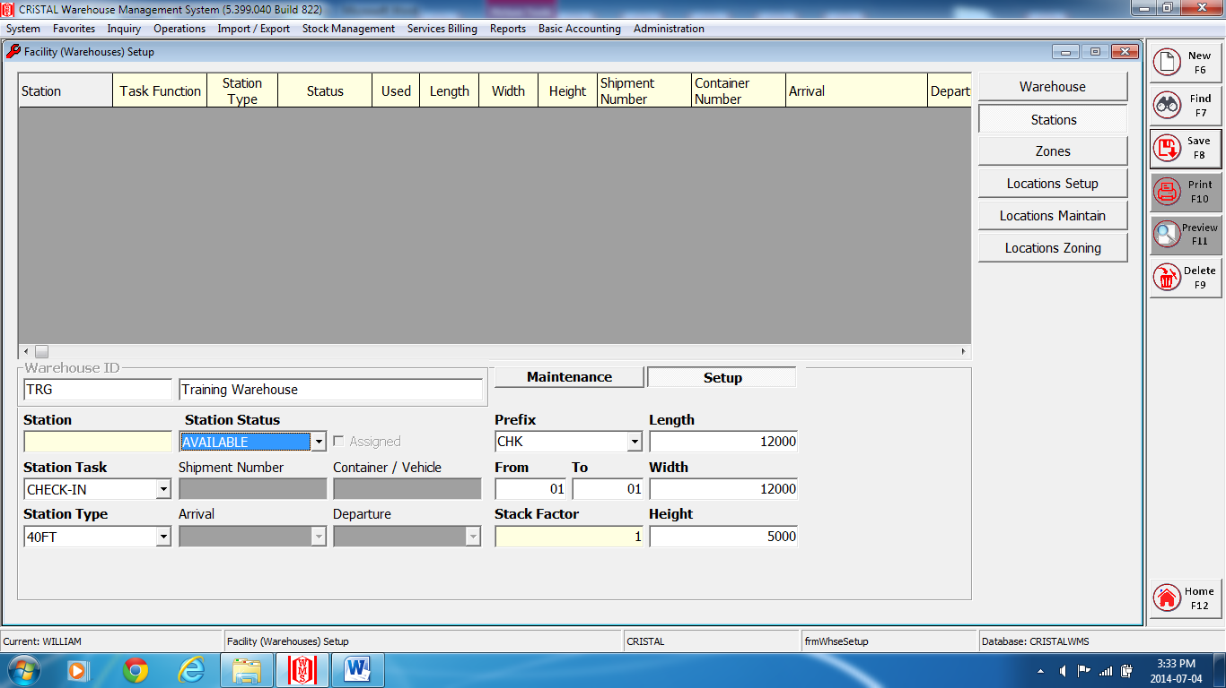
Fig. 1
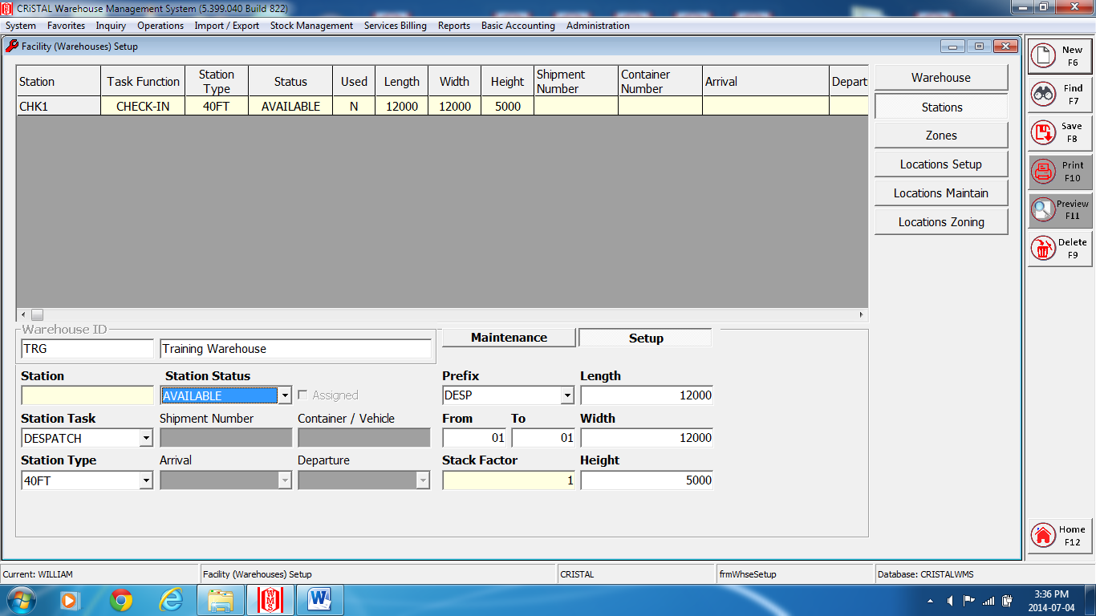
Fig.2
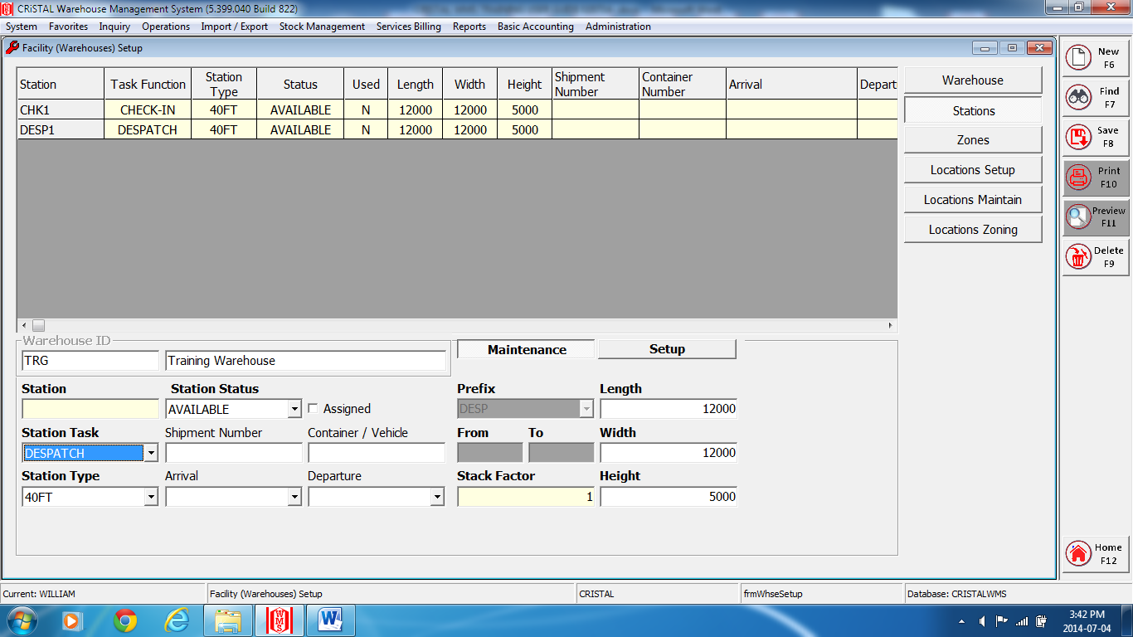
Fig.3
*A Check-In and Dispatch Station must be created*
Set up of Check-In and Dispatch station. (Fig.1 & 2)
- Click on the ‘Setup’ tab.
- Select the preference warehouse at the ‘Warehouse’ field.
- Select the preference status and enter at the ‘Station Status’ field.
- Select and enter the preference task ‘Station Task’ field.
- Select and enter the preference station type at the ‘Station Type’ field.
- Enter the prefix preference at the ‘Prefix’ field.
- Enter a number from and to respectively at the ‘From’ - ‘To’ field.
- Enter the Length, Width and Height in millimeters at their respective fields.
- Enter ‘Save’ or ‘F8’ to complete setup.
Note*: a message ‘Stations created’. Enter ‘OK’.
Maintenance of station (Fig.3)
- Click on the ‘Maintenance’ tab.
- Select and enter the preference warehouse at the ‘Warehouse’ field.
- Select the station for update at the ‘Station’ field,
- Update the fields needed to change.
- Enter ‘Save’ or F8 to complete.
Note*: a message ‘Stations updated’. Enter ‘OK’.
- To delete station, select the Station- rows required and enter ‘Delete’ or F9.
1 – A) WAREHOUSE
iii ) Zones Maintenance
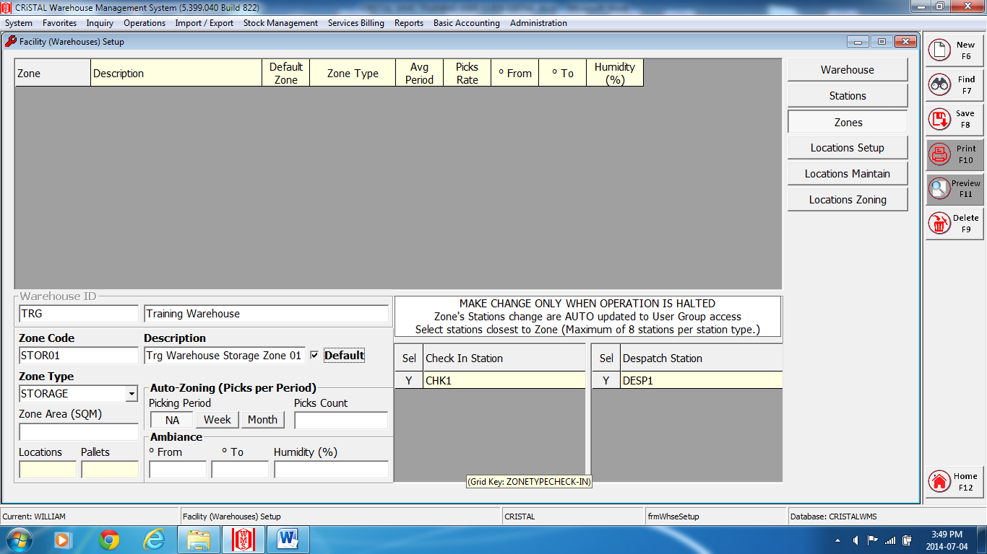
Fig.1
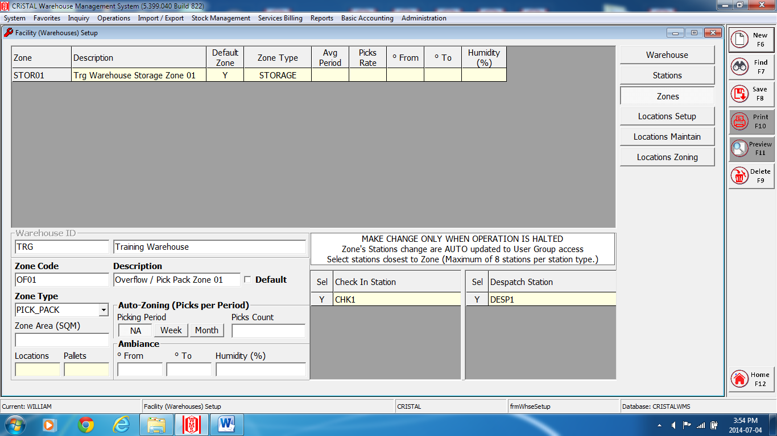
Fig.2
1 – A) WAREHOUSE
iii ) Zones Maintenance

*A Pick_Pack Zone (Overflow Zone) must be created for cross docks or overflow area.*
Set up of a Storage Zone. (Fig.1)
- Select and enter the preference warehouse at the ‘Warehouse’ field.
- Check on the Default Box
- Enter a zone name at the ‘Zone Code’ field.
- Enter the description of the zone code at the ‘Description’ field.
- Select and enter the zone type at the ‘Zone Type’ field.
- At the ‘Sel’ – Check In’ and ‘Sel’ – Dispatch’ station boxes, select the preference station for the zone double click on the row ensuring it change to ‘Y’ to set it as the default .
- Enter ‘Save’ or F8 to complete.
Note*: a message ‘Zone updated’. Enter ‘OK’.

Set up of a Pick_Pack Zone. (Fig.2)
- Select and enter the preference warehouse at the ‘Warehouse’ field
- Enter a zone name at the ‘Zone Code’ field.
- Enter the description of the zone code at the ‘Description’ field.
- Select and enter the zone type at the ‘Zone Type’ field.
- At the ‘Sel’ – Check In’ and ‘Sel’ – Despatch’ station boxes, select the preference station for the zone, double click on the row ensuring it change to ‘Y’ to set it as the default.
- Enter ‘Save’ or F8 to complete.
Note*: a message ‘Zone updated’. Enter ‘OK’.
- Close and exit the page.

1 – A) WAREHOUSE
iv ) Locations Setup
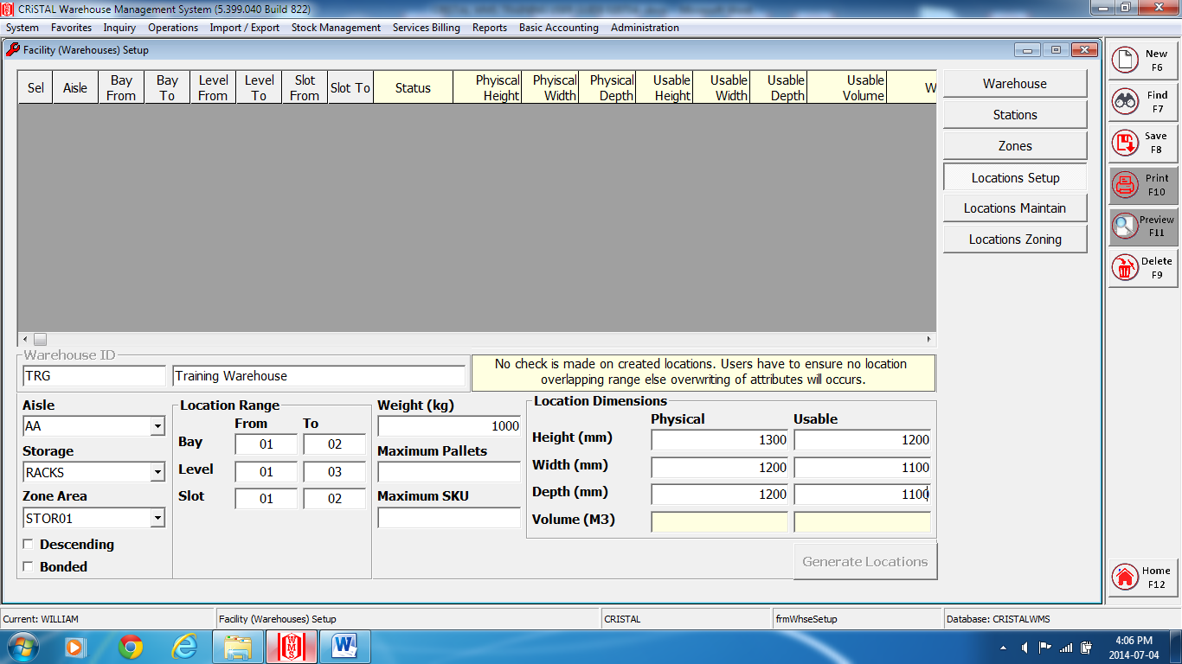
Fig.1
- Select and enter the preference warehouse at the ‘Warehouse’ field.
- Enter an aisle name at the ‘Aisle’ field.
- Select and enter the storage type at the ‘Storage’ field.
- Select and enter the preference zone at the ‘Zone Area’ field.
- Enter the numbers of bay, level and slot at the ‘From’ and ‘To’ Location Range field.
- Enter the measurement in millimeters of the height, width and depth of the storage location at the ‘Physical’ and ‘Usable’ fields.
- Enter the storage location weight in kilogram at the ‘Weight’ field.
- Enter ‘Save’ or ‘F8’ for the numbers of location of the aisle created.(See Fig.2)
- Continue steps 2) to 8) to create new aisle and location.(See Fig.3)
Note*: a location for Pick_Pack zone must be created.
- Select the row or all, double click on each row to ensure it change to ‘Y’.(See Fig.3)
- Click on “Generate Location’ tab to generate the selected locations.
- Click ‘Yes’ to continue when message ‘Commence creation on location matrix’.
- Click ‘OK’ to continue when message ‘Define location generated’.
- Close and exit the page.

1 – A) WAREHOUSE
iv ) Locations Setup
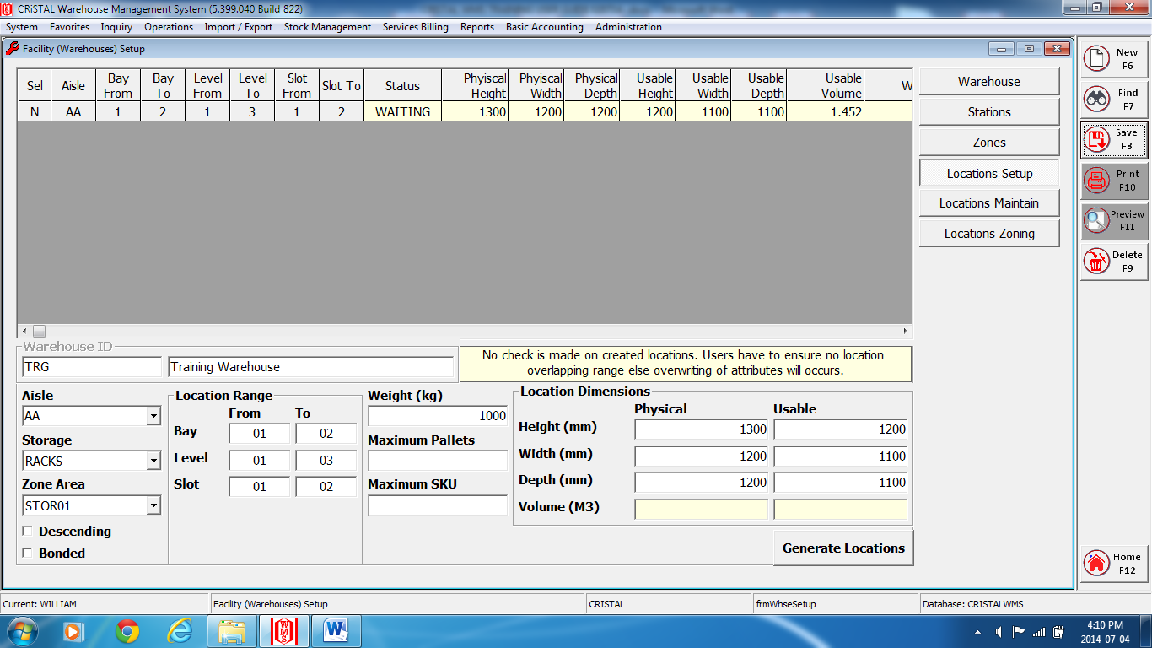
Fig.2
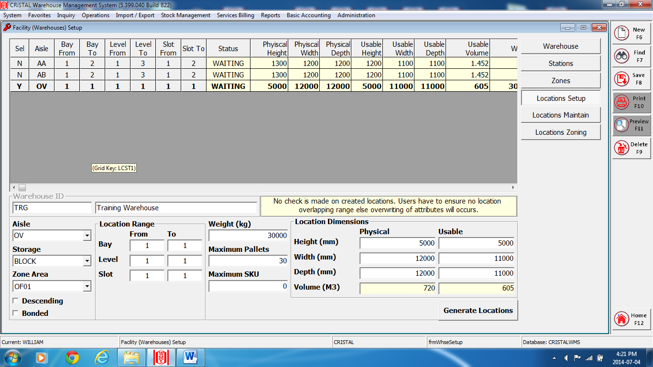
Fig.3
1 – A) WAREHOUSE
v ) Locations Maintenance
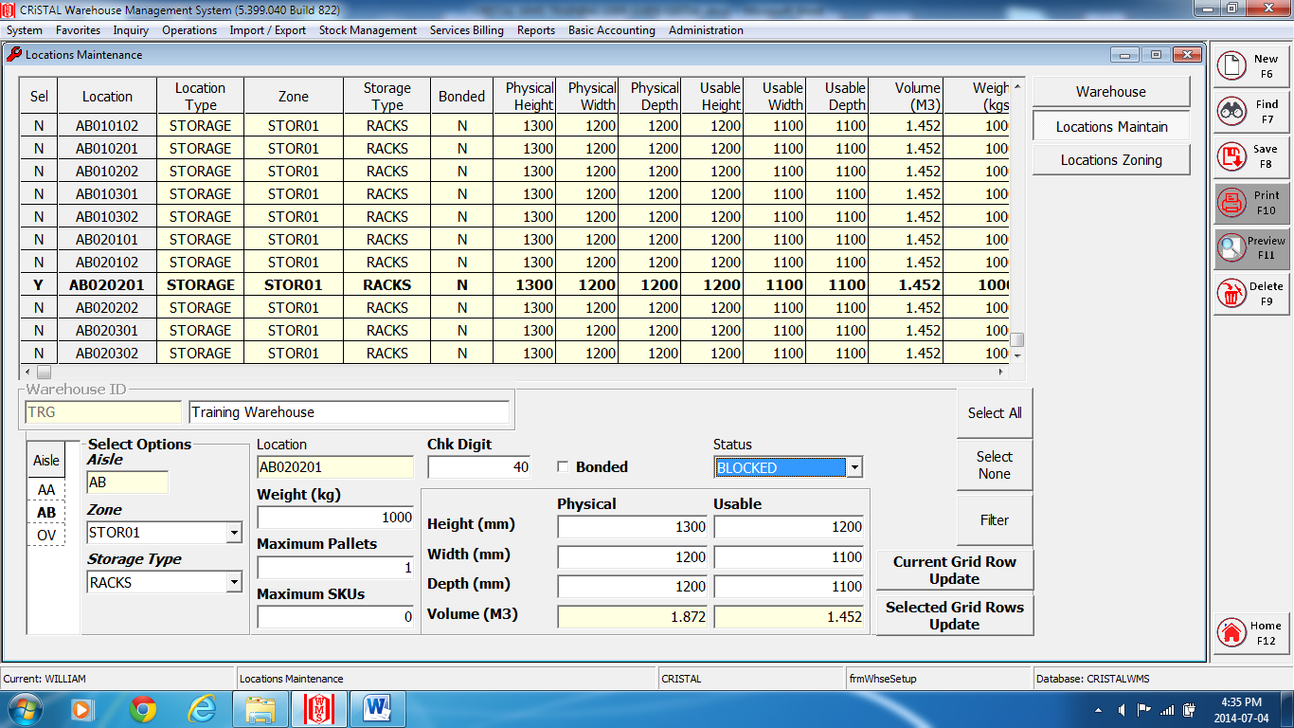

- Select and enter the preference warehouse at the ‘Warehouse’ field.
- Click on the Locations Maintain tab.
- Select the Aisle where the location needed to be updated.
- Select the location, double click on the selected row and ensure the ‘Sel’ column change to ‘Y’.
- Select, enter or update the fields require for changes.
- Click on either the ‘Update Current / Selected Grid Rows’ tabs.
- Enter ‘Save’ or F8 to complete
*Note: a message “Location Modification has been saved on the database” Enter ‘OK’.
- Close and exit the page.

1 – B) Client Entitles
i ) Client Profiles
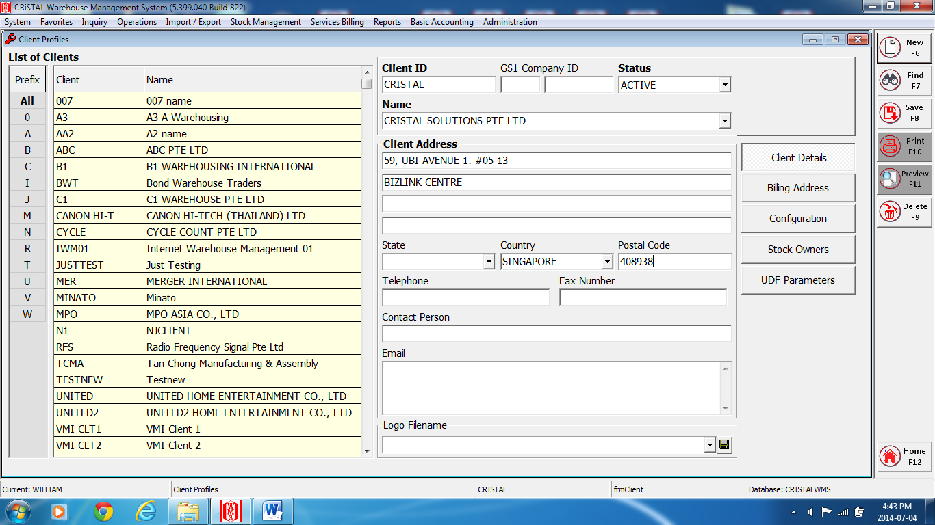
Fig.1
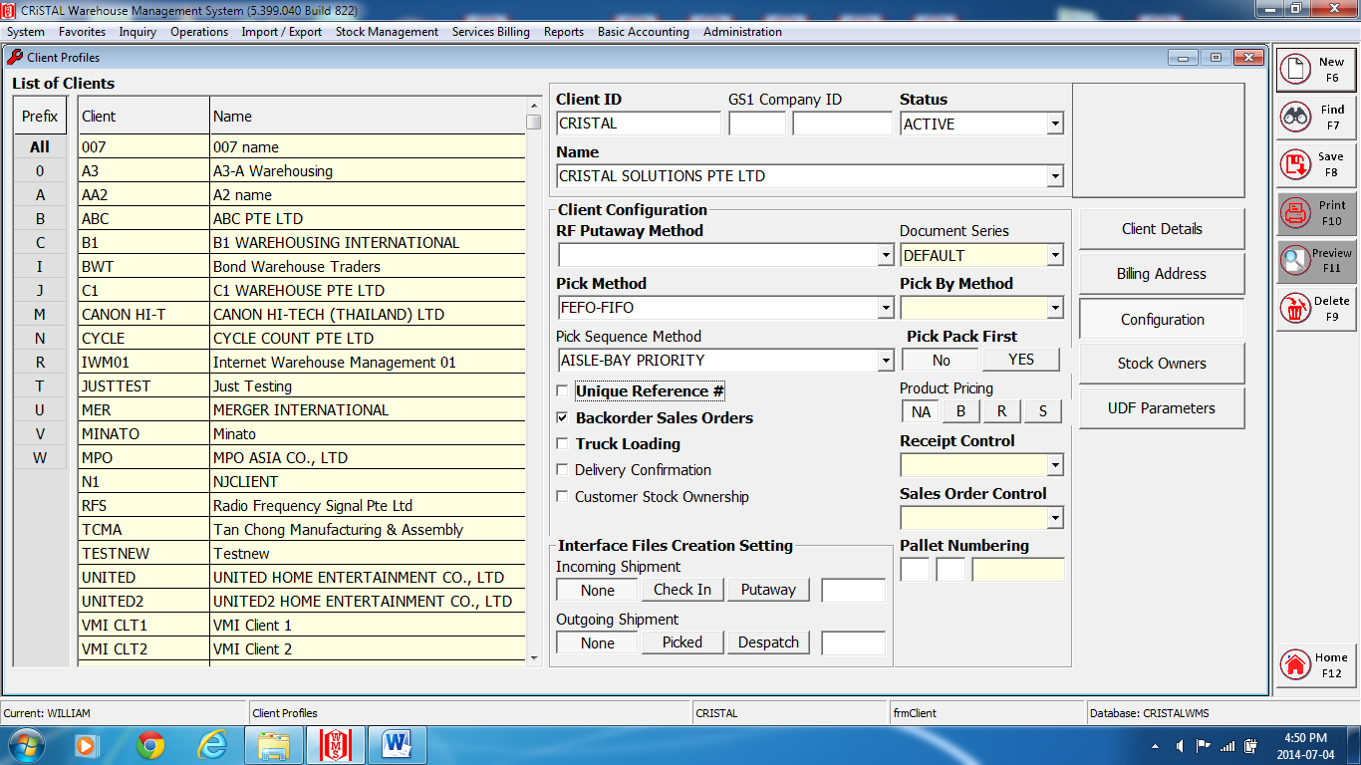
Fig.2

1 – B) Client Entitles
i ) Client Profiles

- At Client Details (Fig.1), enter the preference code in the ‘Client Code’ field.
- Enter the client’s name at the ‘Client Name’ field.
- Enter the address of the client at the ‘Address’ field.
- Select and enter the client’s country at the ‘Country’ field.
- Enter the postal code, if require, at the ‘Postal Code’ field.
- Enter the contact number if any at the ‘Telephone’ field.
- Subsequently, if require, for more information of the client, enter the details at the ‘Fax Number’, ‘Contact Person’ and ‘The Email’ fields.
- Click on the ‘Client Configuration’ tab.
- If require, select and enter the preference put away method at the RF Put-away Method (Fig.2).
- Select and enter the preference document reference at the ‘Document Ref Series’ field.
*Note: If no preferences, select and enter ‘DEFAULT’.
- Select and enter the preference pick method at the ‘Pick Method’ field.
- Select and enter the pick sequence method at the ‘Pick Sequence Method’ field.
- If require check on the boxes next to the preference fields (eg. Backorder Sales Orders).
- Enter ‘Save’ or F8 to complete.
*Note: a message “Client information updated-Cristal.” Enter ‘Yes’.
- If require to update the other information, just click onto the menus tab and enter the preferences field and enter ‘Save’ or F8 to complete.
- Close and exit the page.

1 – B) Client Entitles
ii ) Customer Profiles
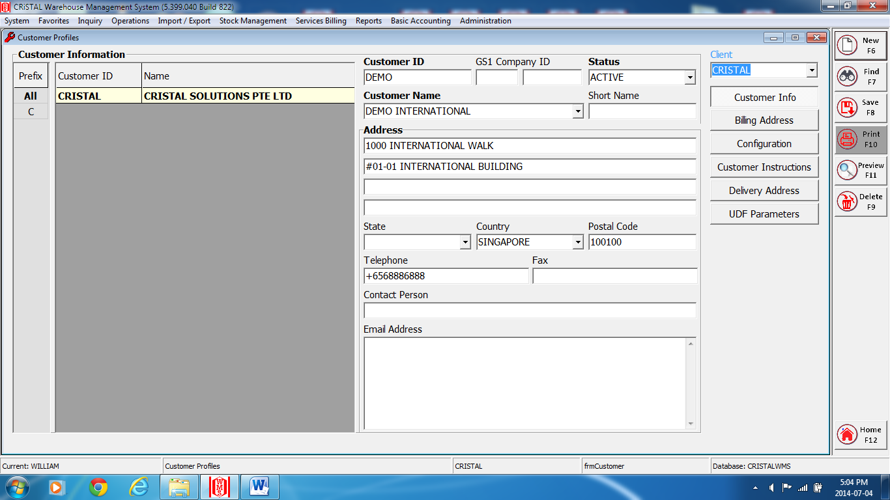
- Select and enter the client of the client’s customer at the ‘Client’ field.
- Enter the customer code at the ‘Customer Code’ field.
- At the Customer Info menu:
- Enter the customer name at the ‘Customer Name’ field.
- Enter the address of the customer at the ‘Address’ field.
- Select and enter the country of the customer at the ‘Country’ field.
- Enter the postal code at the ‘Postal Code’ field.
- If require, enter the information for all the other fields.
- Enter ‘Save’ or F8 to complete.
*Note: a message ‘Customer updated’. Enter ‘OK’.
- Click on the Delivery Address tab if the address is differ from the set up address of the customer.
- Enter ‘Clear’ or F6 and enter the new delivery address at Details 1.
- Click on Details 2 to continue update of information of the delivery address.
- Enter ‘Save’ or F8 to complete.
*Note: a message “Customer updated.” Enter ‘OK’.
- Click other menu tabs, if require, to update data and enter the details at the require fields.
- Enter ‘Save’ or F8 to complete.
*Note: a message “Customer updated.” Enter ‘OK’.
- Close and exit the page.

1 – B) Client Entitles
iii ) Supplier Profiles

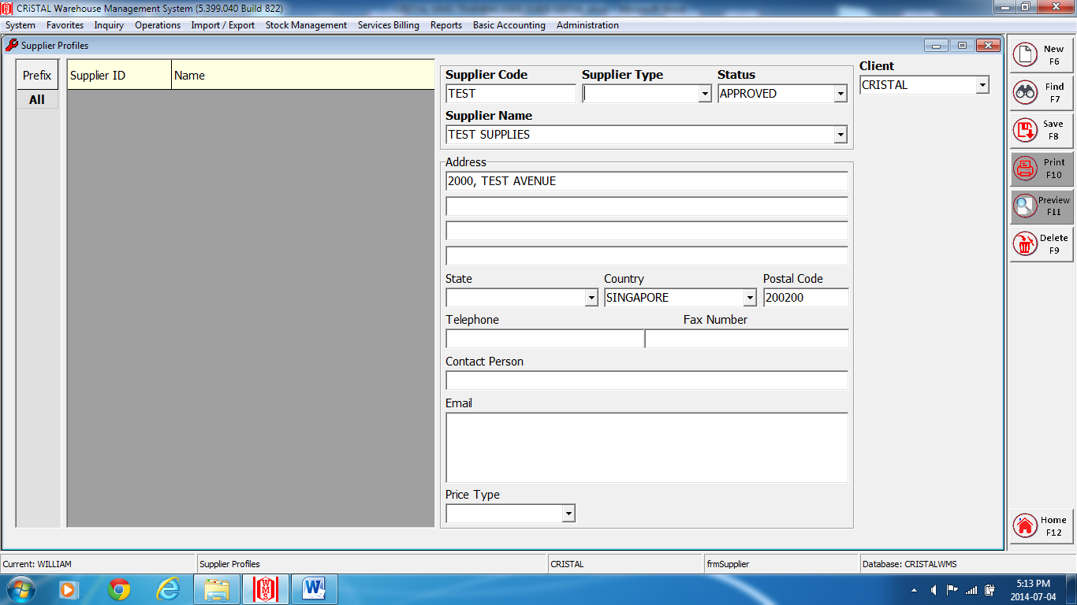

- Select and enter the client at the ‘Client’ field.
- Enter the supplier code at the Supplier Code.
- Select and enter ‘APPROVED’ at the ‘Status’ field.
- At the Address fields:-
- Enter the supplier name at the ‘Supplier Name’ field.
- Enter the address at the ‘Address’ field.
- Select and enter the country at the ‘Country’ field.
- Enter the postal code at the ‘Postal Code’ field.
- If require, enter the information for all the other fields.
- Enter ‘Save’ or F8 to complete.
- Close and exit the page.

1 – C) Users
i ) User Groups
(Menus)

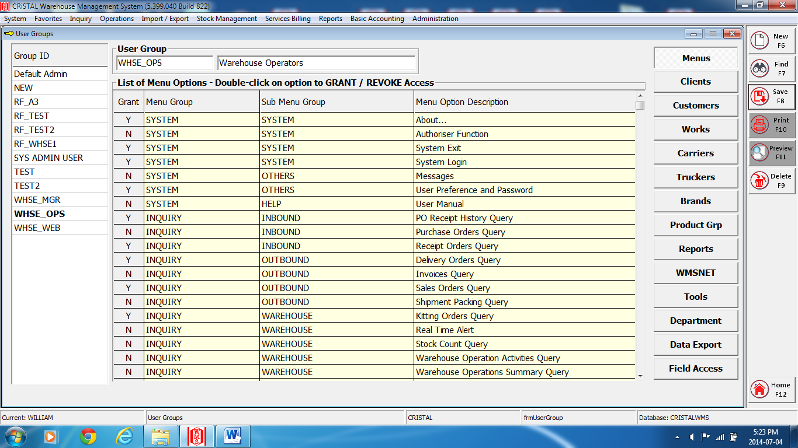

- Click on the ‘Menus’ tab.
- Enter a group’s name at the ‘User Group’ field.
- Enter the description of the user group at the next field.
*Note a message “Copy authorized accesses from user group”. Enter Yes
- Click on the checkbox option to Grant authorize access for the Menu Group.
- Enter ‘Save’ or F8 to complete.
*Note a message “Excess Granted / Updated for User Group xxxxx”. Enter ‘OK’.
Follow by a message “Updated members of group xxxxx”. Enter OK.

1 – C) Users
i ) User Groups
(Clients)

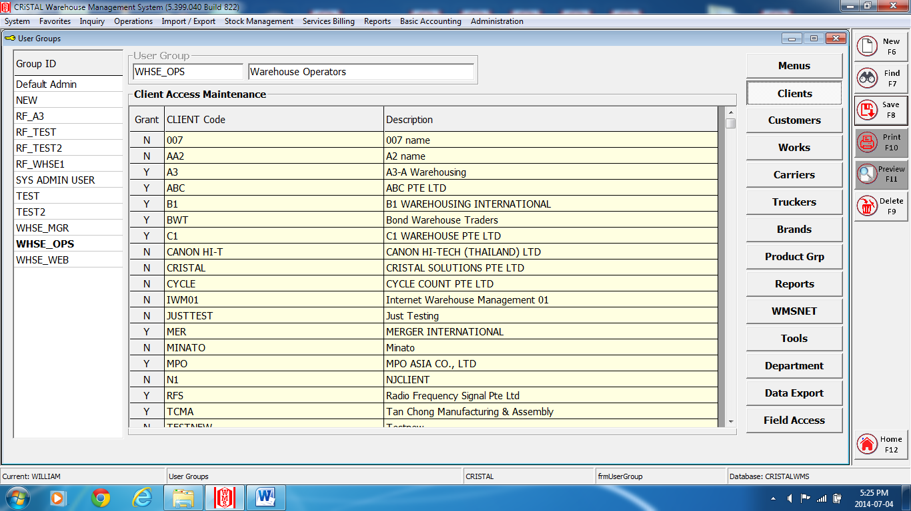

- Click on the ‘Clients’ tab.
- Click on the checkbox option to Grant authorize access for the Client Code.
- Enter ‘Save’ or F8 to complete.
*Note a message “Excess Granted / Updated for User Group xxxxx”. Enter ‘OK’.
Follow by a message “Updated members of group xxxxx”. Enter OK.

1 – C) Users
i ) User Groups
(Customers)

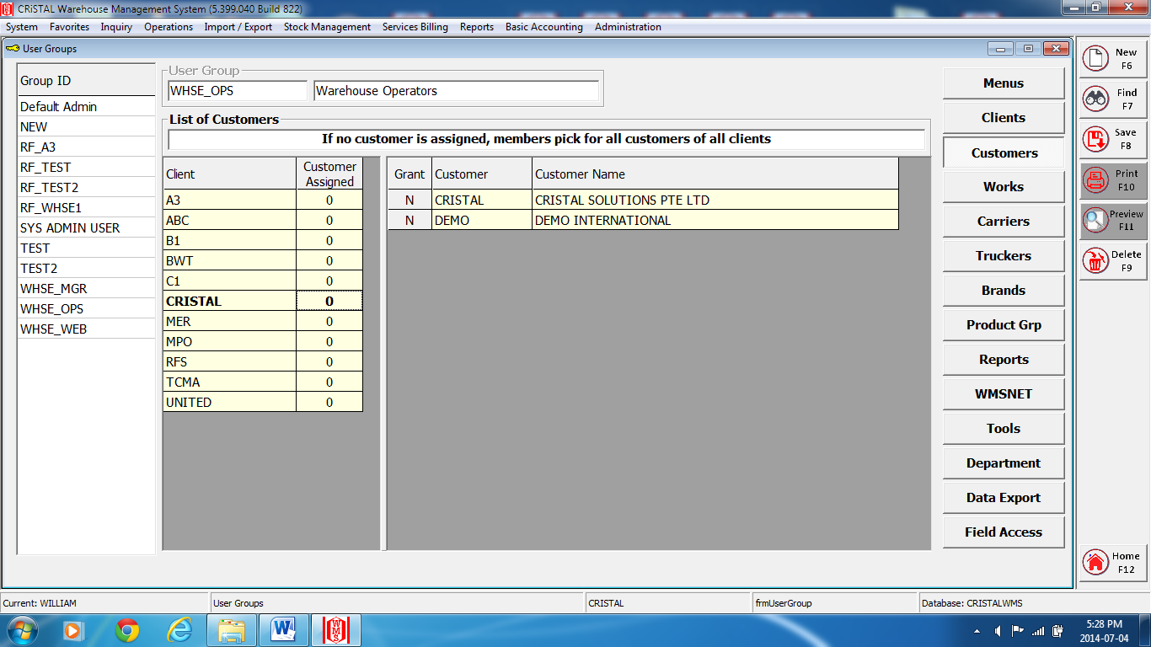

- Click on the ‘Customers’ tab.
- Select and click on the Client option at the List of customers’ box.
- Click on the checkbox option to Grant authorize access for the Client Code.
If no customer is assigned, the selected user group will be granted access to all clients’ customer.
- Enter ‘Save’ or F8 to complete.
. *Note a message “Excess Granted / Updated for User Group xxxxx”. Enter ‘OK’.
Follow by a message “Updated members of group xxxxx”. Enter OK.

1 – C) Users
i ) User Groups
(Works)

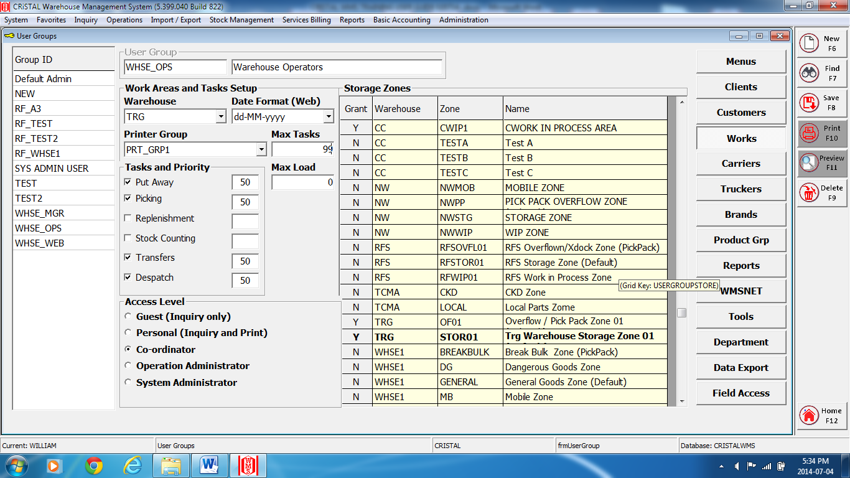

- Click on the ‘Works’ tab.
- Click on the checkbox to authorize the task and priority option at the Task and Priority menu.
*Note: Priority 10 to 99 is from the lowest to the highest priority respectively.
- Click on the checkbox at the Access Level menu to grant authorization access for the selected group.
- Click on the checkbox option to Grant authorize access for the Warehouse, Zone.
- If require, select and enter information at the prefer fields.
- Enter ‘Save’ or F8 to complete.
. *Note a message “Excess Granted / Updated for User Group xxxxx”. Enter ‘OK’.
Follow by a message “Updated members of group xxxxx”. Enter OK.
- Close and exit the page.

1 – C) Users
i ) User Groups
(Others MENU)

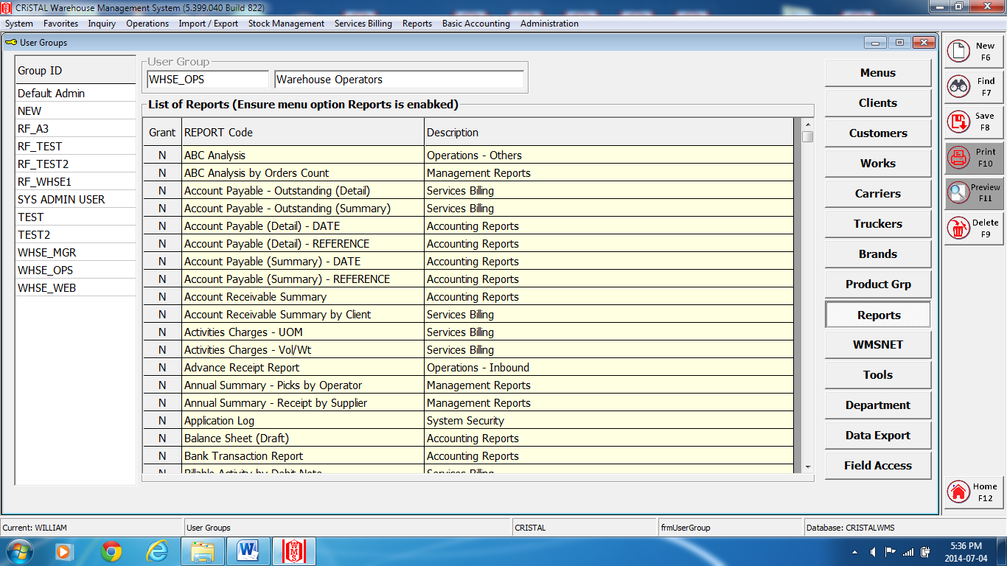

*NOTE: “OPTIONAL”. IF REQUIRE, CONTINUE TO SELECT AND ENTER THE NECESSARY INFORMATIONS, DATA OF THE SELECTED MENU.

1 – C) Users
i ) User Profiles

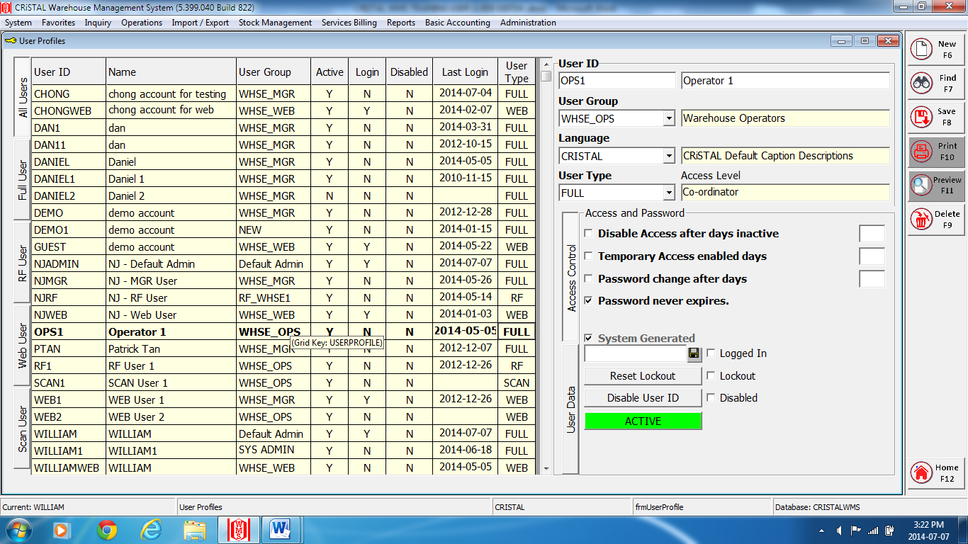

- Enter a user description at the ‘User’ field.
- Enter the user name next to the ‘User’ field.
- Select and enter the user group at the ‘User Group’ field.
- Select and enter ‘Cristal’ at the ‘Language’ field.
- Select and enter the user type at the ‘User Type’ field.
- Click on the selected checkbox option and the System Generated checkbox (uncheck it if password is given manually.) at the Access Control, Access and Password menu.
- If require, at the User Data and Login History menus, continue to select and enter the necessary informations.
- Enter ‘Save’ or F8 to complete.
*Note a message “User profile updated Default Password xxxxxxxx”. Take note of this password (for system generated). Enter ‘OK’.
- Click on the ‘INACTIVE” tab to change the user to ‘ACTIVE’ status.
*Note a message “Update user profile?” Enter ‘Yes’.
Follow by a message ‘User profile updated’. Enter ‘OK’.
- Click on the ‘Disable User ID’ tab to update this function.
- Click on the ‘Reset Lockout’ tab to update this function.
- Close and exit the page,

1 – D) Products
i ) Product Item / Definition
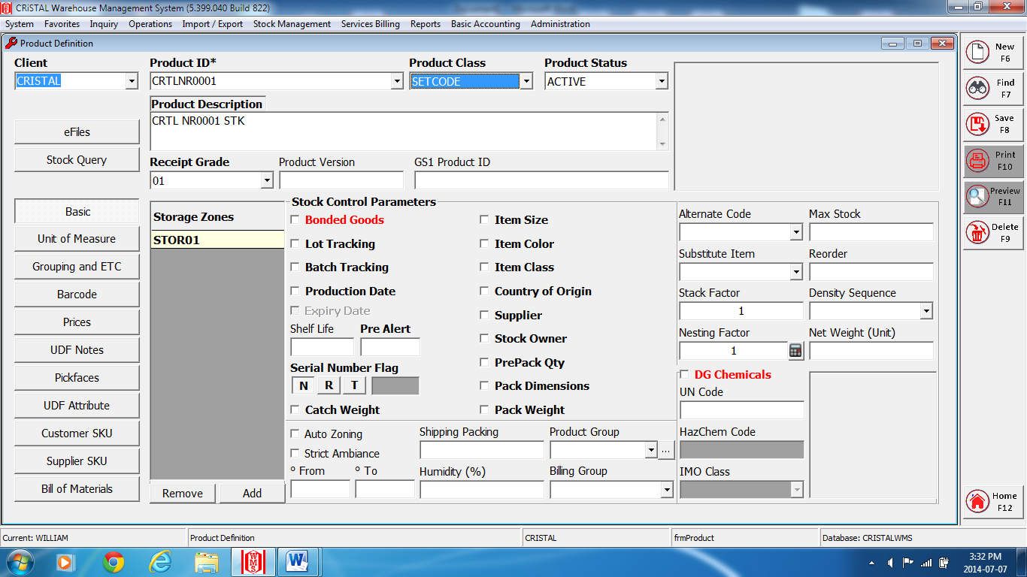
Fig.1
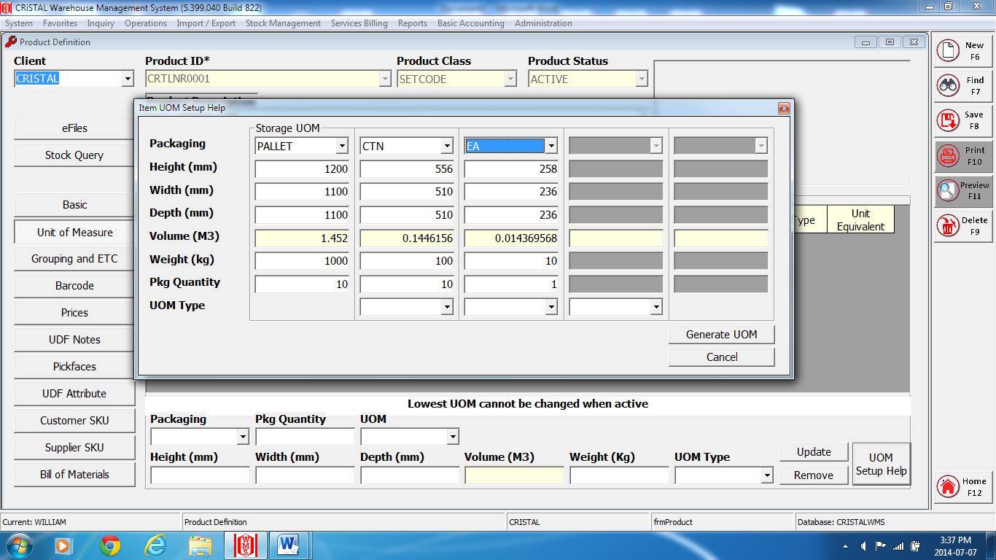
Fig.2
1 – D) Products
i ) Product Item / Definition

- Select and enter a client name at the ‘Client’ field. (Fig.1)
- Enter the item number/code at the ‘Product ID’ field.
- Enter the item description at the Item ‘Description’ field.
- Select and click on the checkbox option at the Stock Control Parameters menu.
- Click on the ‘Add’ tab at the Assigned Storage Zones
- Select and enter the preferences storage zone assign to.
- Click on the ‘Unit of Measure’ tab for item UOM Setup.
- Click on the ‘UOM Setup Help’ tab.
- At the Item UOM Setup Help screen, the first level (column) Storage UOM (Fig.2), packaging field must remain as “PALLET”. Proceed to enter the dimensions (in millimeters) of the height, width, depth, weight (in kilograms) and the packaging quantity of the full storage packaging on one pallet at the respective fields. Note*: The Volume (in cu.m) will be automatically calculated.
- Select and enter the packaging UOM type (eg.: Ctn, bags, etc.) at the second level.
- Enter the quantity of per package at the Pkg Quantity field.
Note*: you can continue to set up another level of packaging UOM but it must be in a lower packaging quantity form.
- Click on the UOM Generate tab for the next level of UOM packaging setup.
Note*: a message ‘Please ensures all fields are specified’. Enter ‘OK’.
- Select and enter the lowest UOM of the product / item (eg. Ea, pcs, meter, etc.), at the last level of the UOM setup.
- Click on the ‘UOM Generate’ tab to complete the UOM setup.
- Enter ‘Save’ or F8 to complete.
Note*: a message “Item code updated”. Enter ‘OK’
Follow by a message “Update transactions history’s UOM dimensions and weight? Enter ‘Yes’.
- If require, proceed to select and enter the information of each menus.
Note*: Always enter ‘Save’ or F8 to complete updating of each menu.
- Close and exit the page.

2 – System
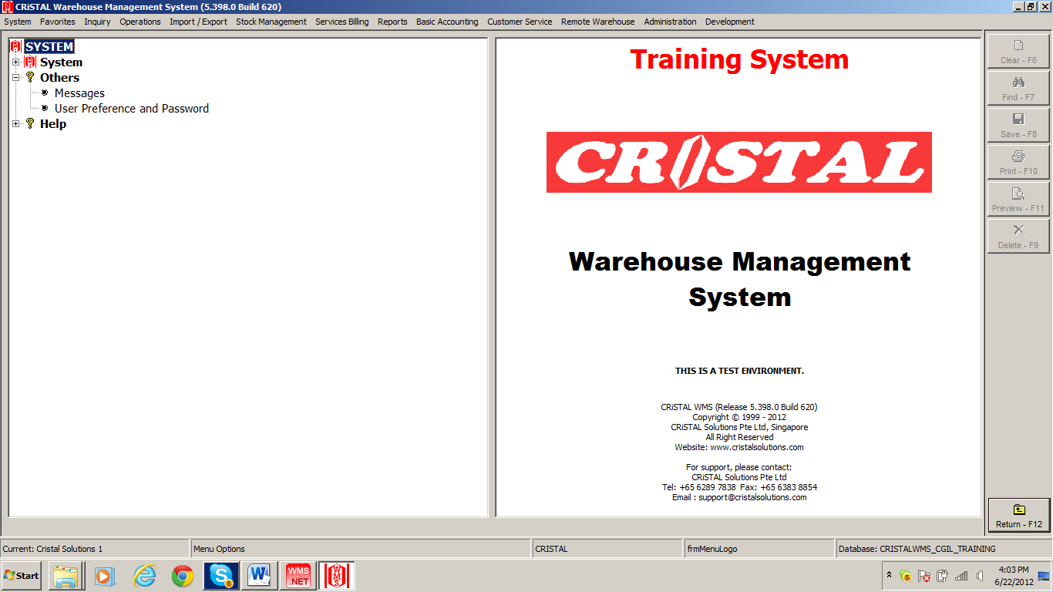

Change a User password.

Others
- User Preference and Password

2 – Others
i ) User Preference and Password

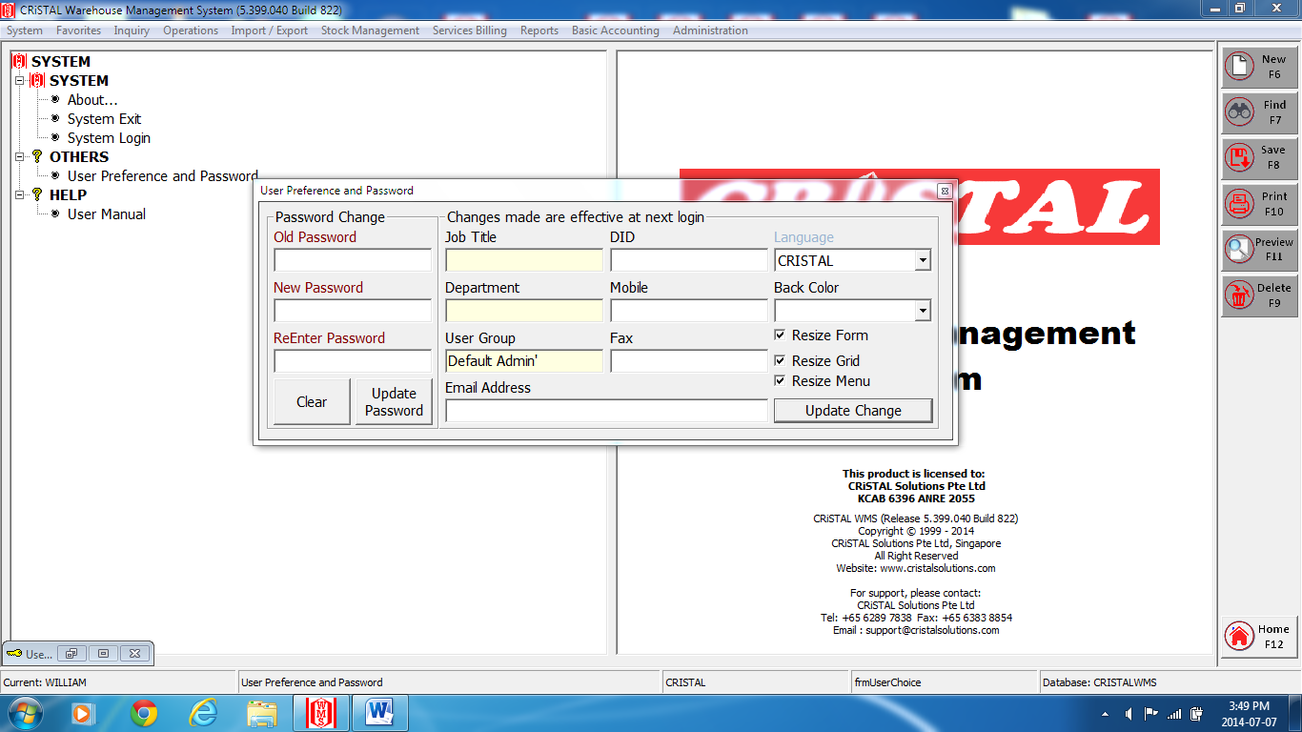

- Click on the User Preference and Password menu.
- Enter the current user password at the ‘Enter Old Password’ field.
- Enter the new user password at the ‘Enter New Password’ field.
- Enter again the new password at the ‘Re-Enter New Password’ field.
- Click on the ‘Update Password’ tab to save the new password.
- Click on the ‘Close’ tab to exit.

3 – Operations
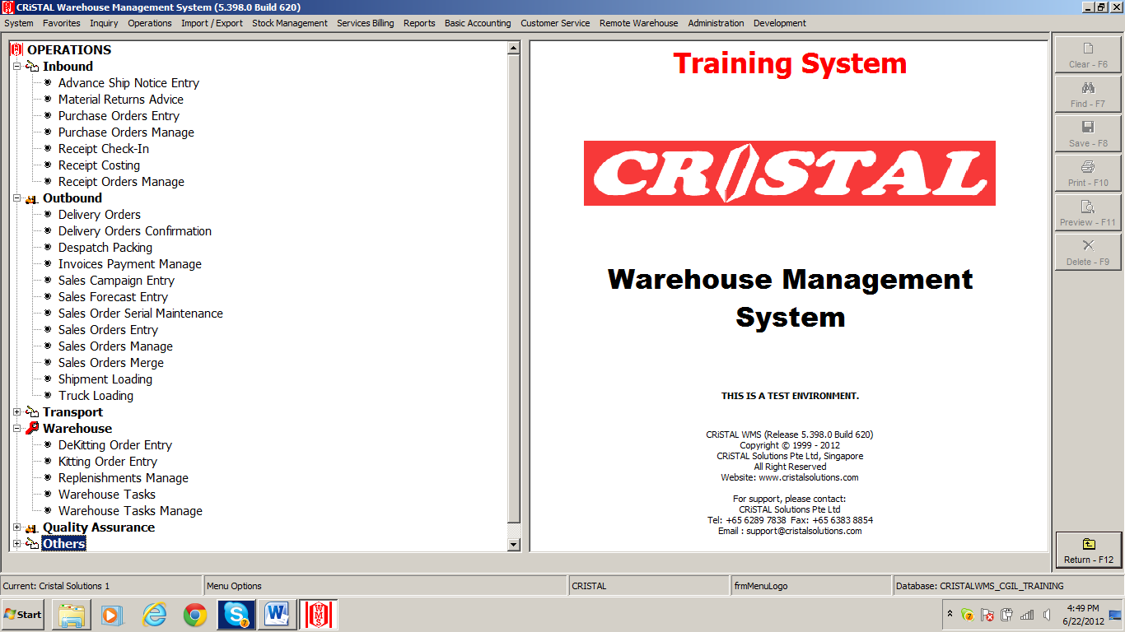
B
A
C

Manage receiving, storage, picking operation.

- Inbound
- Receipt Check-In
- Warehouse
- Warehouse Tasks
- Outbound
- Sales Orders Entry
- Delivery Orders

3 – A) Inbound
i ) Receipt Check-In
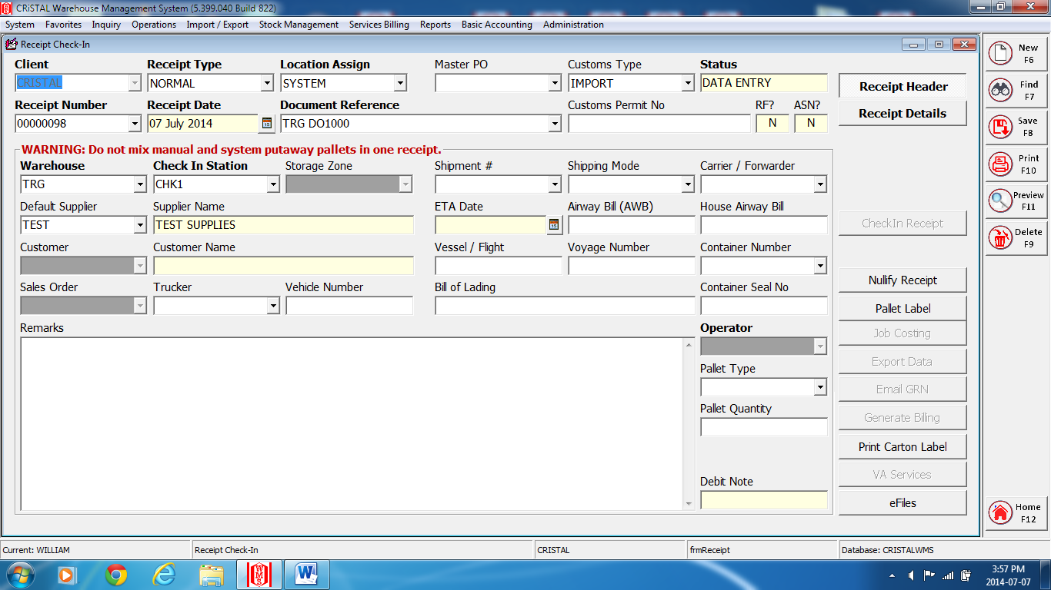
Fig. 1
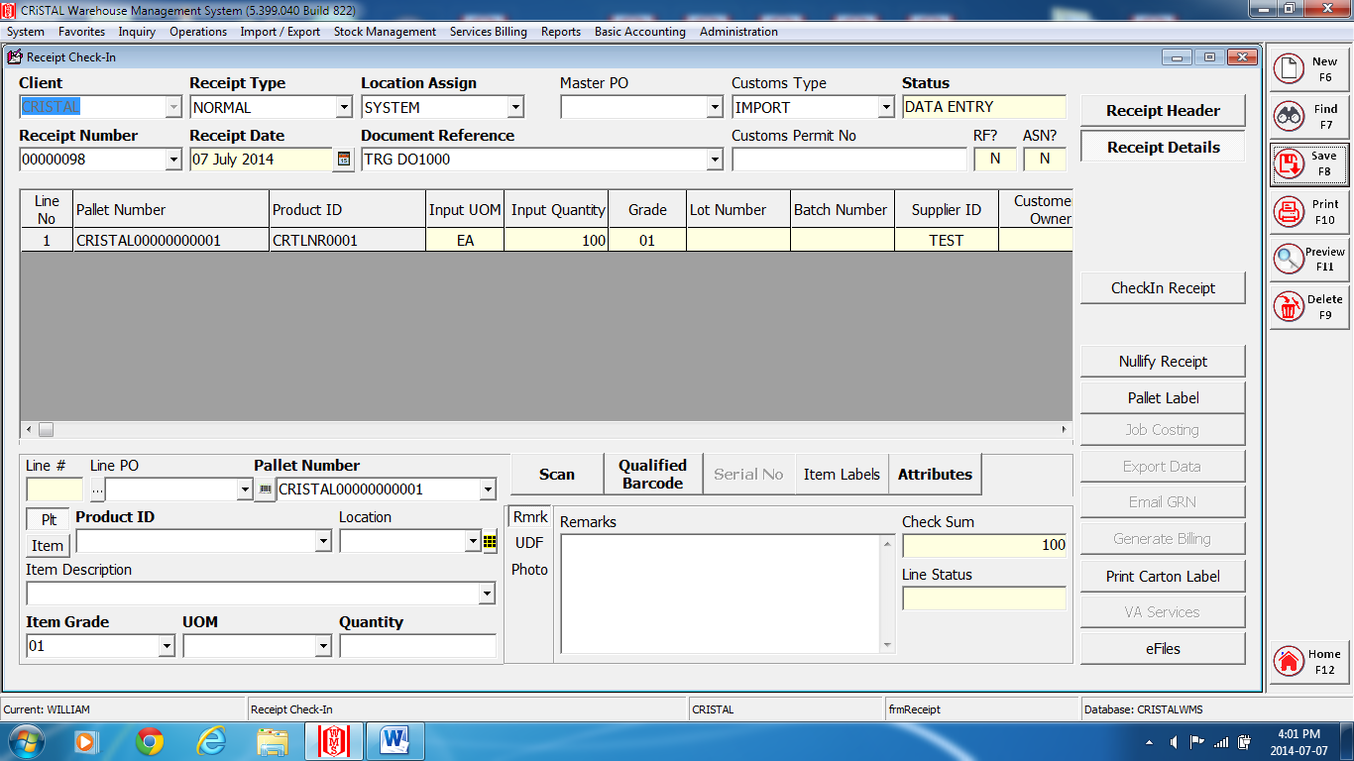
Fig.2
3 – A) Inbound
i ) Receipt Check-In
- Receipt Header (Fig.1)
- Select and enter the requested client at the ‘Client’ field.

- Select and enter the method of receiving into location at the ‘Location Assign’ field.
- By System means location to put-away is assign by the system.
- By Manual means location to put-away is assign manually.
- Enter the reference number of the receiving document at the ‘Document Reference’ field.
- Select and enter the supplier at the ‘Default Supplier’ field. (Optional)
- Enter ‘Save’ or F8.
Note*: a message, ‘Update New Receipt’. Enter ‘Yes’.
A receipt number will then be generated by the system.

- Receipt Details (Fig.2)
- Click on the ‘Receipt Details’ tab.
- Select and enter the product/item code at the ‘Item Code’ field.
- Enter the quantity received at the ‘Quantity’ field.
- Items which has attribute, enter the attributes at their respective fields.
- For Manual Location Assign, enter and select the location at the ‘Location’ field to be put-away.
For System Location Assign, proceed to step 6.
- Enter ‘Save’ or F8 to save line item.
- Enter ‘Clear or F6 to proceed to the next new line item.
- Continue step 2 to 7 till complete receiving of whole order.
- Click on the ‘Checkin Receipt’ tab.
- For System Location Assign:
Note*: a message ‘Receipt detail entry completed?’. Enter ‘OK’.
Follow by message ‘Confirm receipt for Put-away’. Enter ‘Yes’.
And the last message ‘Receipt Checked In’. Enter ‘OK’.
*Proceed to Warehouse - Warehouse Task menu to complete confirming of put-away into locations.*
- Manual Location Assign:
Note*: a message ‘Receipt detail entry completed?’. Enter ‘OK’.
Follow by message ‘Number of lines process:’ Enter ‘OK’.
No further actions require for manual location assign.
- Close and exit the page.

3 – B) Warehouse
i ) Warehouse Tasks
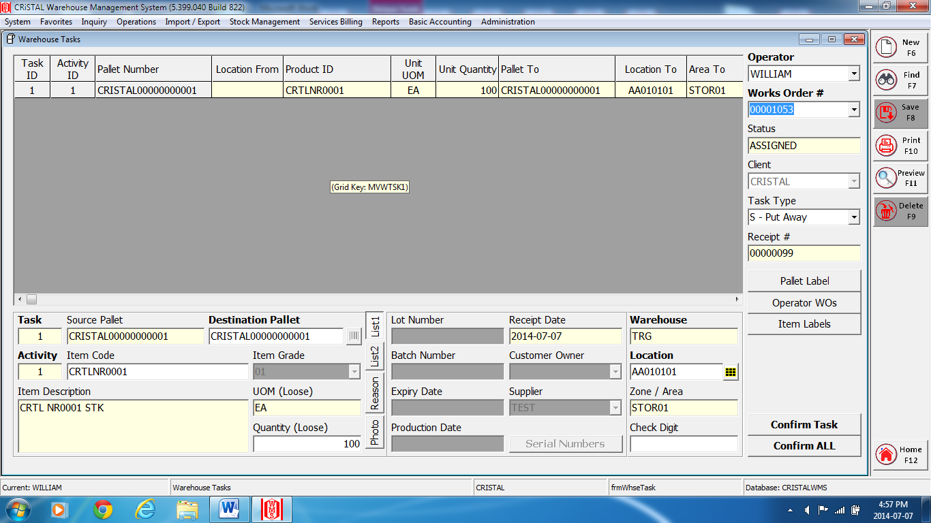

- Click on the drop down box of the ‘Work Order #’ field.
- Select the required ‘Receipt # or Sales/Transfer Order’ line.
- Click on the ‘Select’ tab.
- a) Select the Task ID to confirm that particular task only. Click on the ‘Confirm Task’ tab.
b) Click on the ‘Confirm All’ tab to confirm all the ID Task.
Note* a message ‘Work Order confirmed’. Enter ‘OK’.
- Close and exit the page.

3 – C) Outbound
i ) Sales Order Entry
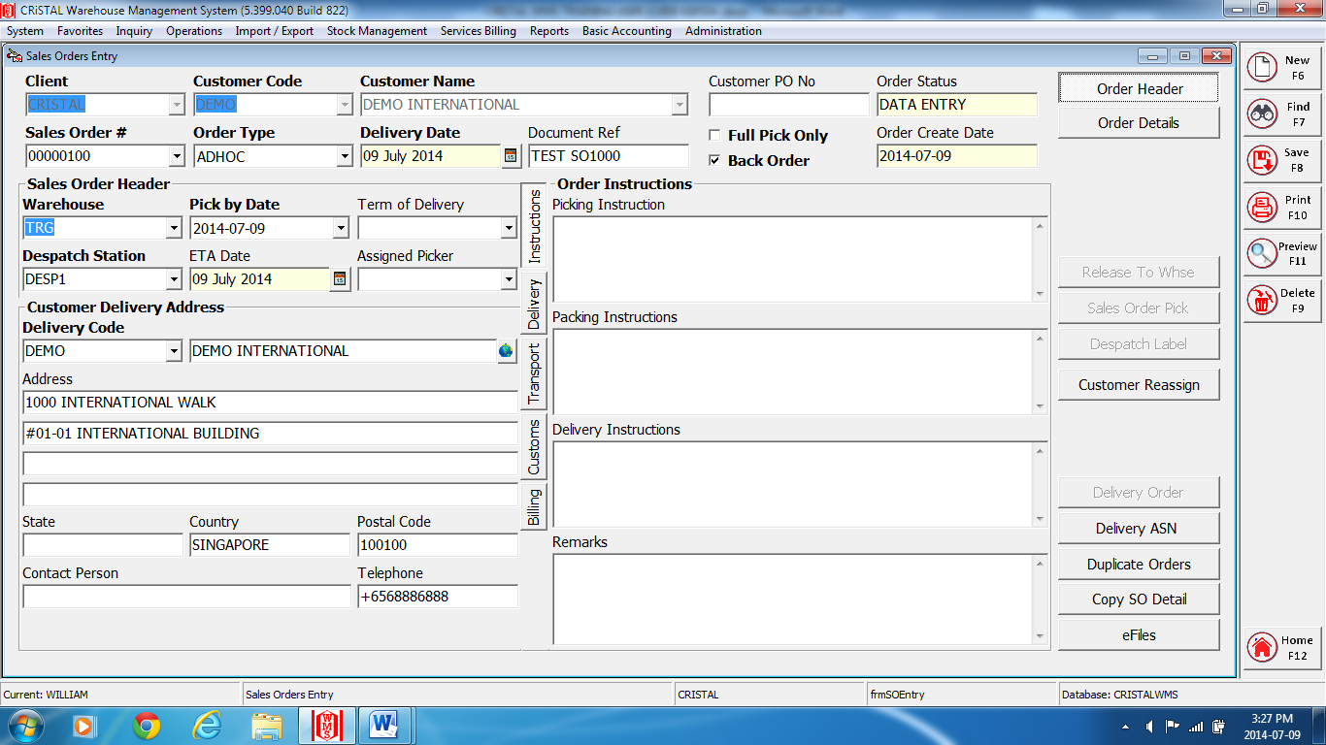
Fig.1
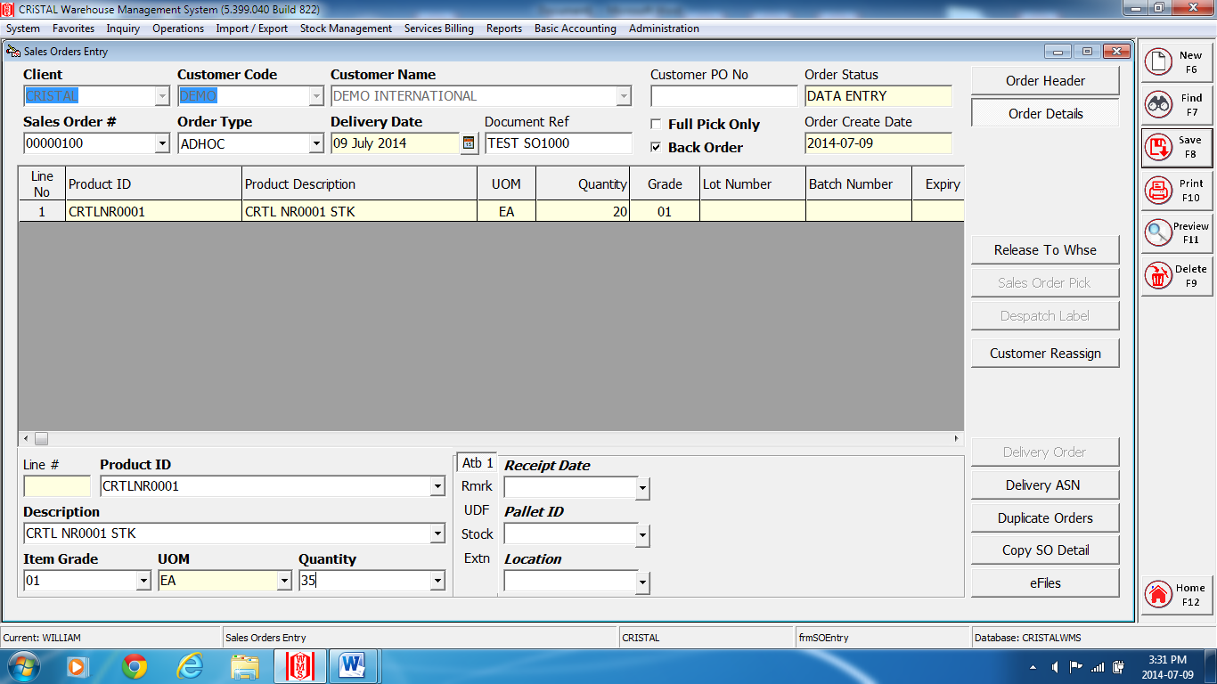
Fig.2
3 – C) Outbound
i ) Sales Order Entry
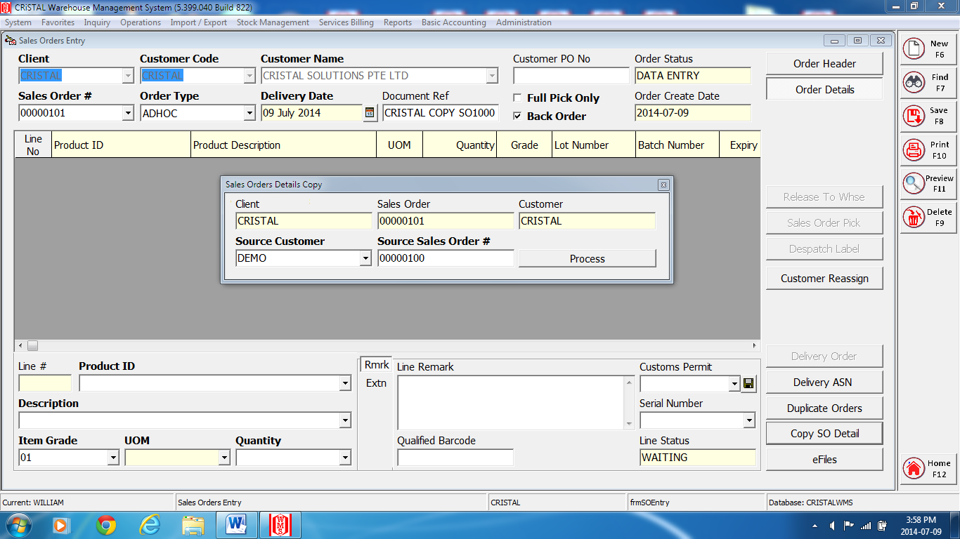
Fig.3
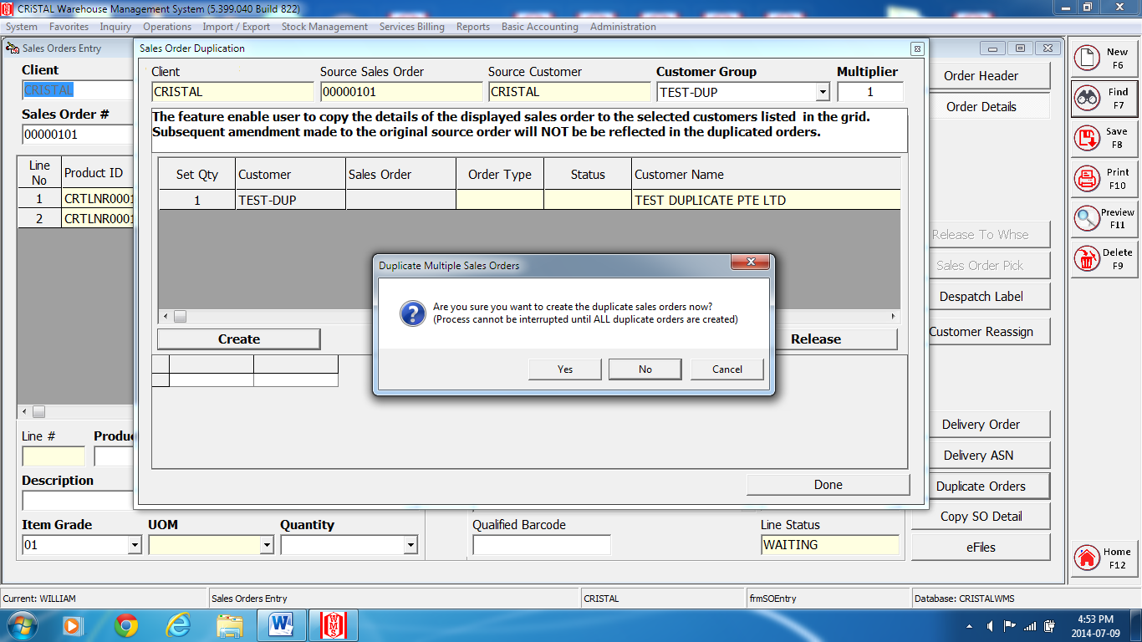
Fig.4
3 – C) Outbound
i ) Sales Order Entry
- Order Header (Fig.1)
- Select and enter the requested client at the ‘Client’ field.
- Select and enter the customer at the ‘Customer Code’ field.
- Enter the reference number at the ‘Document Reference’ field.
- Enter ‘Save’ or F8.
Note*: a message ‘Create new Sales Order? ‘. Enter ‘Yes’.

- Order Details (Fig.2)
- Click on the ‘Order Details’ tab.
- Select and enter the product/item number at the ‘Item Code’ field.
- Enter the quantity to pick at the ‘Quantity’ field.
- Items which has attribute, enter the attributes at their respective fields.
- Enter ‘Save’ or F8 to save line item.
- Enter the F6 or click on the ‘New’ tab before proceed to next item line.
- Continue step 2 to 6 till complete creating of whole order.
- Click on the ‘Release To Whse’ tab,
Note*: a message ‘Sales Order released for picking’. Enter ‘OK’.
Follow by message ‘Generate Pick Tasks Now?’ Enter ‘Yes’.
And the last message ‘Sales Order processed’. Enter ‘OK’.
- Click on the ‘Sales Order Pick’ tab.
Note*: a message ‘Assign Picks Orders?’
Enter ‘Yes’- a Warehouse Task (SO) screens appear:-
a) Select the Task ID to confirm that particular task only. Click, on the ‘Confirm Task’ tab.
b) Click on the ‘Confirm All’ tab to confirm all the ID Task.
Note*: a message ‘Work Order confirmed’. Enter ‘OK’.
Exit page if picking tasks is done later.
- Close and exit the page.
- “REMEMBER” when picking tasks is completed, *Proceed to Warehouse - Warehouse Task* menu to complete confirming of picking tasks.

c) Copy SO Details (Fig.3)
- After complete steps 1 – 3 at, a) ‘Order Header’ click on the ‘Order Details’ tab.
- At ‘Order Details’, click on the ‘Copy SO Details’ tab.
- At the ‘Sales Orders Details Copy’ screens. Select and enter the Customer and Sales order number to copy at the ‘Source Customer’ and ‘Source Sales Order #’ fields respectively.

3 – C) Outbound
i ) Sales Order Entry

c) Copy SO Details (Fig.3), cont’d.

4) Click on the ‘Process’ tab.
Note*: a message ‘Sales order (Cristal 0000000xxx) details copied from SO (0000000xxx).
Enter OK.
5) Continue steps 8 – 10 at b) ‘Order Details’ to complete.

d) Duplicate Order (Fig.4)

1) Select and enter the requested client at the ‘Client’ field.
2) At ‘Order Header’, select and enter the customer at the ‘Customer Code’ field.
3) Enter the previous intended sales order number to duplicate at the ‘Sales Order #’ field.
4) Enter ‘Find’ or F7 to reflect the sales order number specify.
5) Click on the ‘Order Details’ tab.
6) Click on the ‘Duplicate Order’ tab.
7) At the ‘Sales Order Duplication’ screen:-
i) Select and enter the customer at the ‘Customer Group’ field.
ii) Click on the ‘Create’ tab.
Note*: a message, see Fig.4. Enter ‘Yes’.
iii) Click on the ‘Release’ tab.
Note*: a message ‘Generate Pick Task at the same time?’ Enter ‘Yes’.
iv) Click on the ‘Done’ tab.
7) “REMEMBER” when picking tasks is completed, *Proceed to Warehouse – Warehouse
Task* menu to complete confirming of picking tasks.

3 – C) Outbound
ii ) Delivery Orders

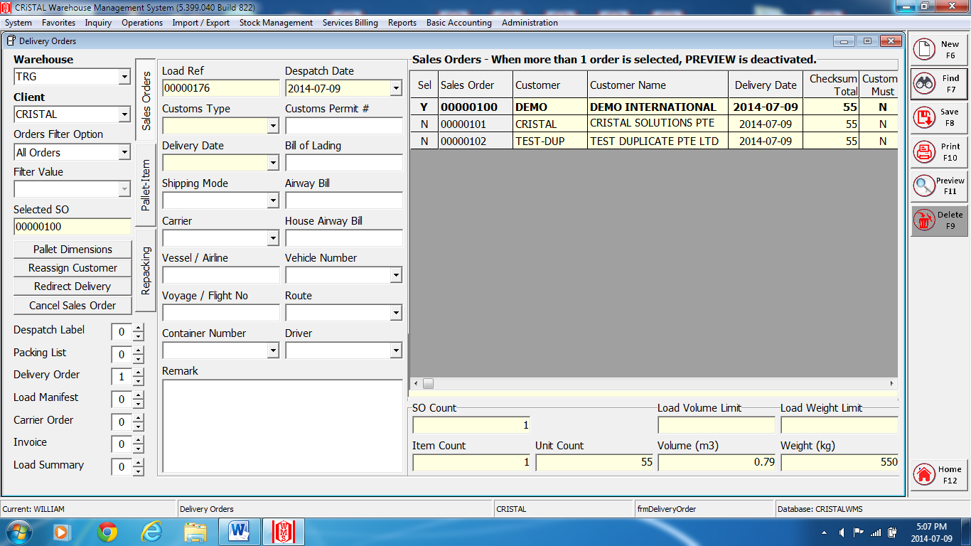

- Select and enter the warehouse at the ‘Warehouse’ field
- Select and enter the client at the ‘Client’ field.
- Select the ‘Sales Order’, double clicks on the selected row and ensures the ‘Sel’ column change to ‘Y’.
- Select and enter the numbers of delivery order require at the ‘Delivery Order’ field.
- Enter ‘Preview’ or F11 to complete.
- Note*: a message ‘Pallets updated’. Enter ‘OK’.
- Close and exit the page.

4 – Inquiry

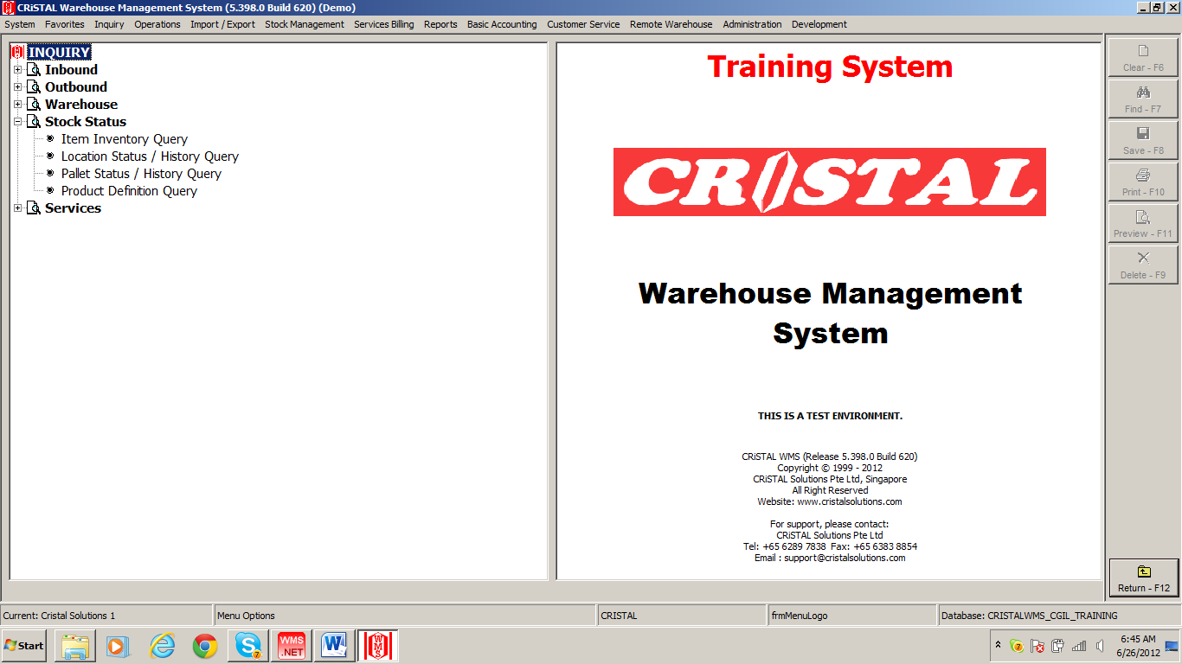
A

Query for stock, location status.
- Stock Status
- Item Inventory Query
- Location Status / History Query
- Pallet Status / History Query
- Product Definition Query

4– A) Stock Status
i ) Item Inventory Query

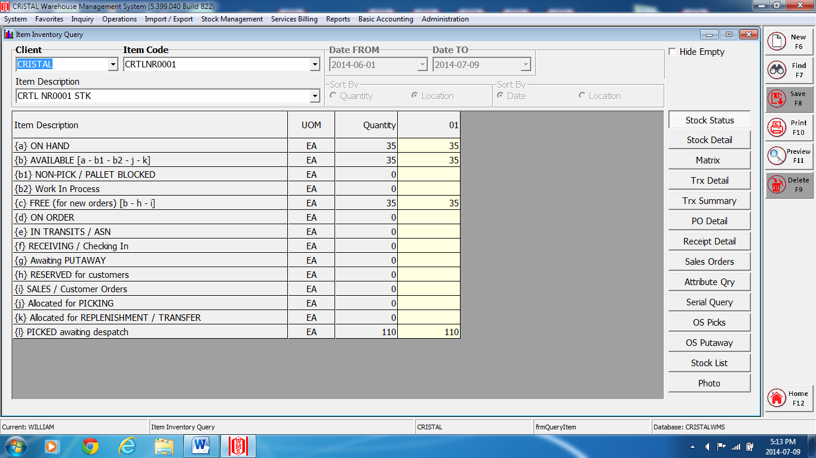

- Select and enter the client at the ‘Client’ field.
- Select and click on the respective tabs for their queries.
- Select and enter information if require at some of the queries.
- Close and exit the page.

4– A) Stock Status
ii ) Location Status / History Query

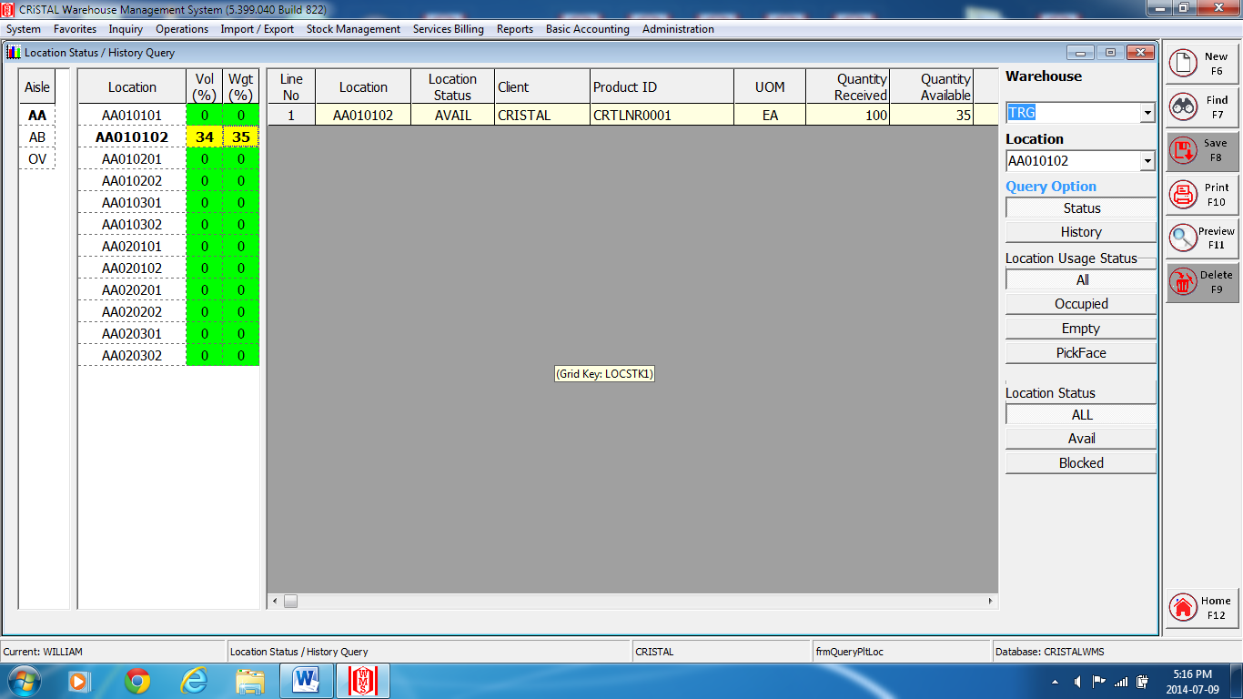

- Select and enter the warehouse at the ‘Warehouse’ field.
- Select and enter the Aisle and the location for particular location status query.
- Alternately, click on the tabs at the Location Usage Status for their respective queries.
- Click on the ‘History’ tab at the Option Query field for its histories information.
- Select and enter dates from and to at the ‘Start Date’ and ‘End Date’ respectively.
- Select and click on either ‘Date’ or ‘Item’ tab at the ‘Sort By’ field.
- Select and enter the Aisle and the location require for query.
- Close and exit the page.

4– A) Stock Status
iii ) Pallet Status / History Query

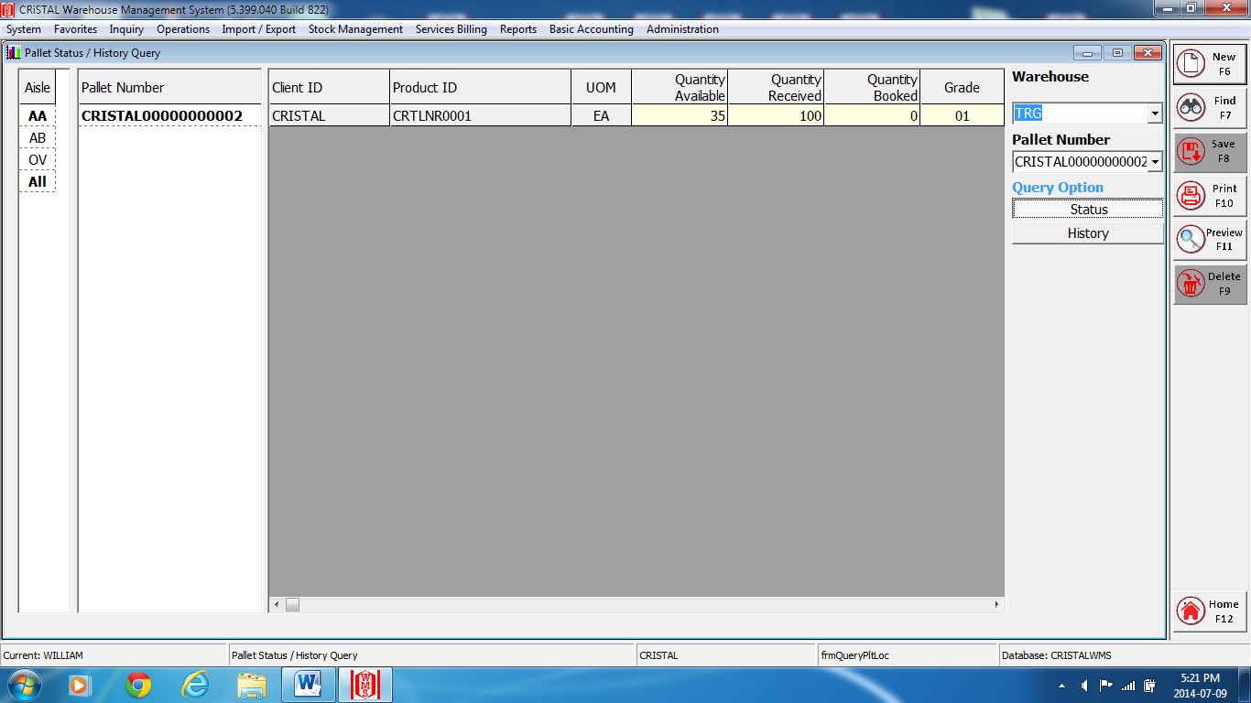

- Select and enter the warehouse at the ‘Warehouse’ field.
- Select and enter the Pallet number at the selected Warehouse column (left) OR
enter the first few prefix of the pallet number at the ‘Pallet #’ field and then click on the drop down box and double click on the require pallet number.
- Click on the ‘History’ tab at the Option Query field for its histories information.
- Select and click on either ‘Date’ or ‘Item’ tab at the ‘Sort By’ field.
- Repeat step 2.
- Close and exit the page

4– A) Stock Status
iv ) Product Definition Query

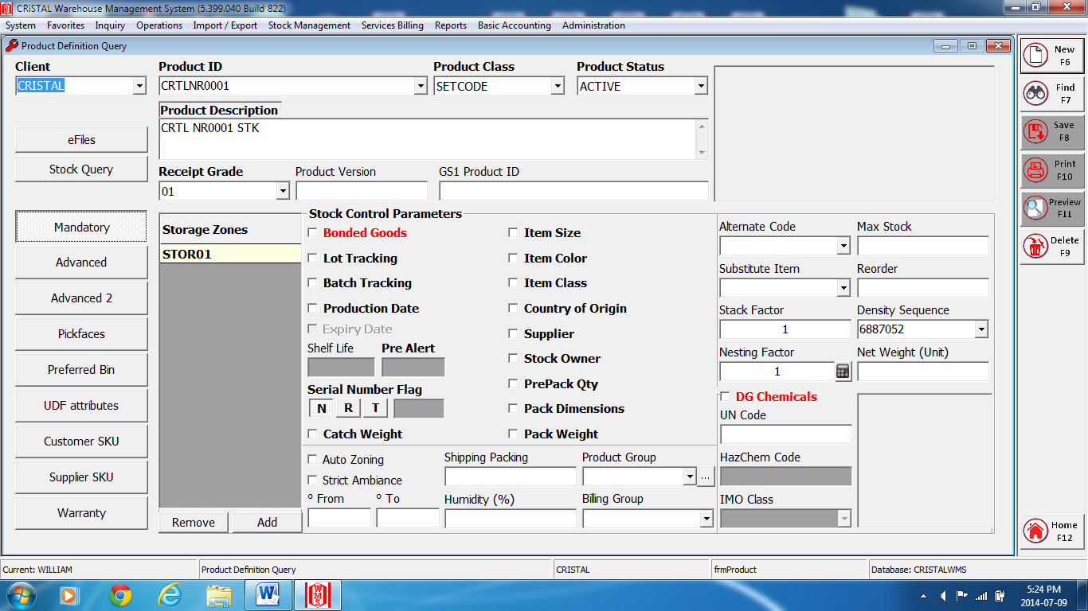

- Select and enter the client at the ‘Client’ field.
- Select and enter the product / item number at the ‘Item Code’ field.
- Select and click on the respective tabs for their queries.
- Close and exit the page.

5 – Stock Management

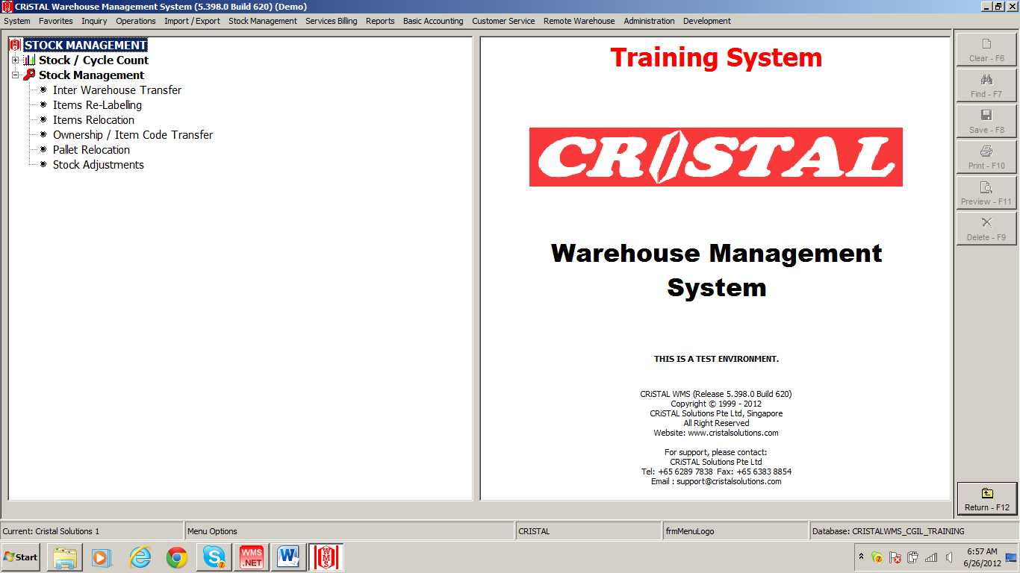
A

Managing of stock transfers, attributes changes and adjustments.

- Stock Management
- Items Re-labeling
- Items Relocation
- Pallet Relocation
- Stock Adjustments

5– A) Stock Management
i ) Items Re-labeling

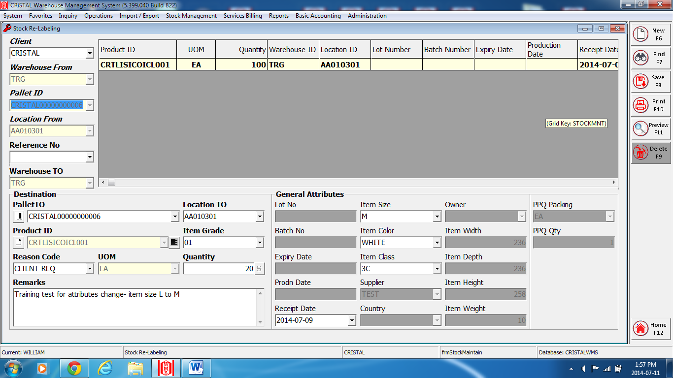

- Select and enter the client at the ‘Client’ field.
- Select and enter the pallet ID at the ‘Source Pallet’ field.
- Select and enter the change attribute at the ‘General Attributes’ field.
- Enter the change quantity at the ‘Quantity’ field if require.
- Select and enter the reason at the ‘Reason Code’ field.
- Enter ‘Save’ or F8 to complete.
Note*: a message ‘Item Re-label updated’. Enter ‘OK’.
- Close and exit the page.

5– A) Stock Management
ii ) Items Relocation

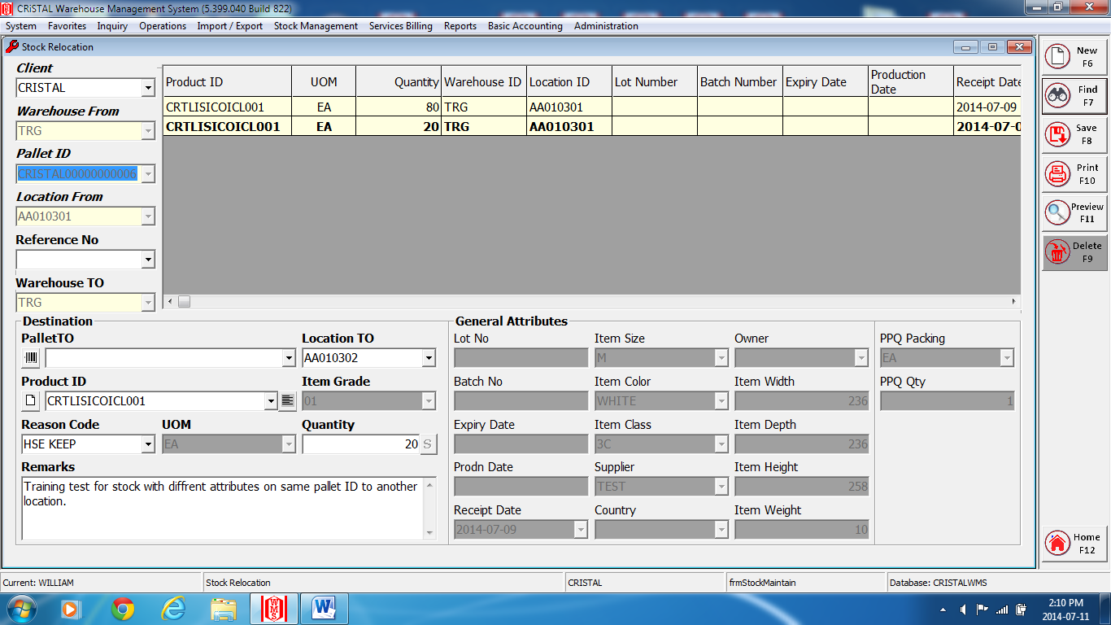

- Select and enter the client at the ‘Client’ field.
- Select and enter the pallet ID at the ‘Source Pallet’ field.
- Select or enter the location for item transfer to at the ‘Destination- Location To’ field.
- Enter the quantity to transfer at the right of the ‘Quantity’ field.
- Select and enter the reason at the ‘Reason Code’ field.
- Enter ‘Save’ or F8 to complete.
Note*: a message ‘Item Transfer updated’. Enter ‘OK’.
- Close and exit the page.

5– A) Stock Management
iii ) Pallet Relocation

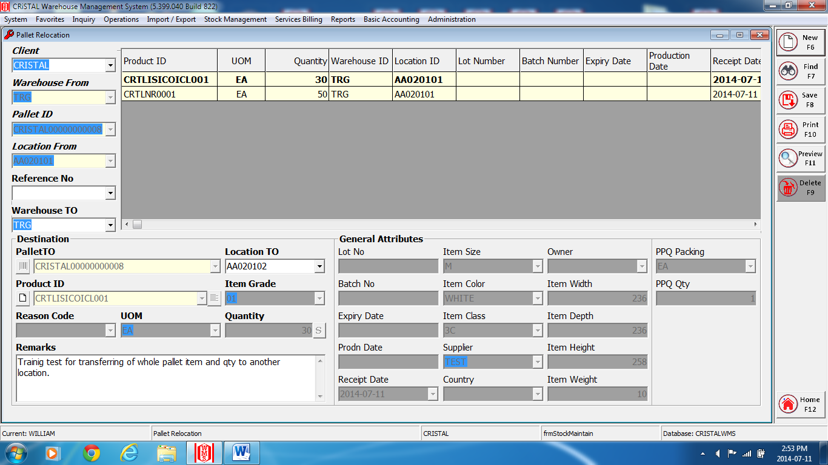

- Select and enter the client at the ‘Client’ field.
- Select and enter the pallet ID at the ‘Source Pallet’ field.
- Select or enter the location to transfer to at the ‘Destination- Location To’ field.
- Enter ‘Save’ or F8 to complete.
Note*: a message ‘Pallet Transfer updated’. Enter ‘OK’.
- Close and exit the page.

5– A) Stock Management
iv ) Stock Adjustments

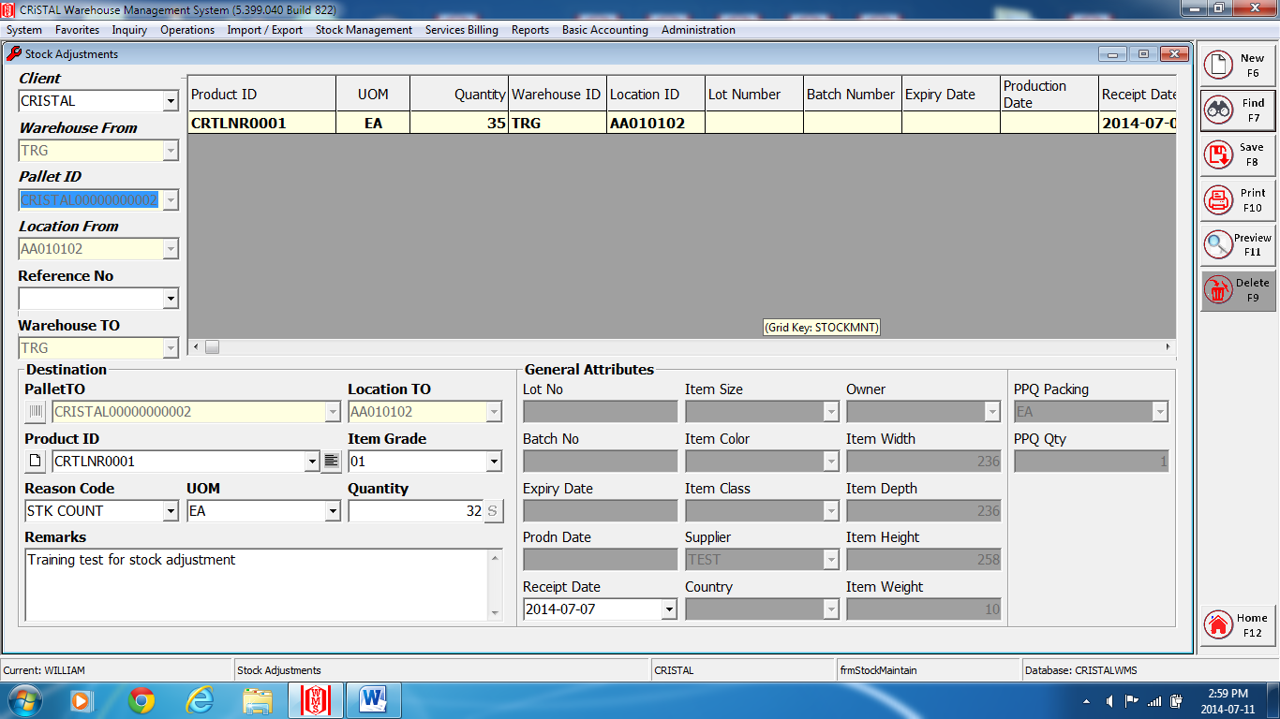

- Select and enter the client at the ‘Client’ field.
- Select and enter the pallet ID at the ‘Source Pallet’ field.
- Enter the quantity adjusted to at the right of the ‘Quantity’ field.
- Select and enter the reason at the ‘Reason Code’ field.
- Enter ‘Save’ or F8 to complete.
Note*: a message ‘Item stock adjusted’. Enter ‘OK’.
- Close and exit the page.

6 – Reports

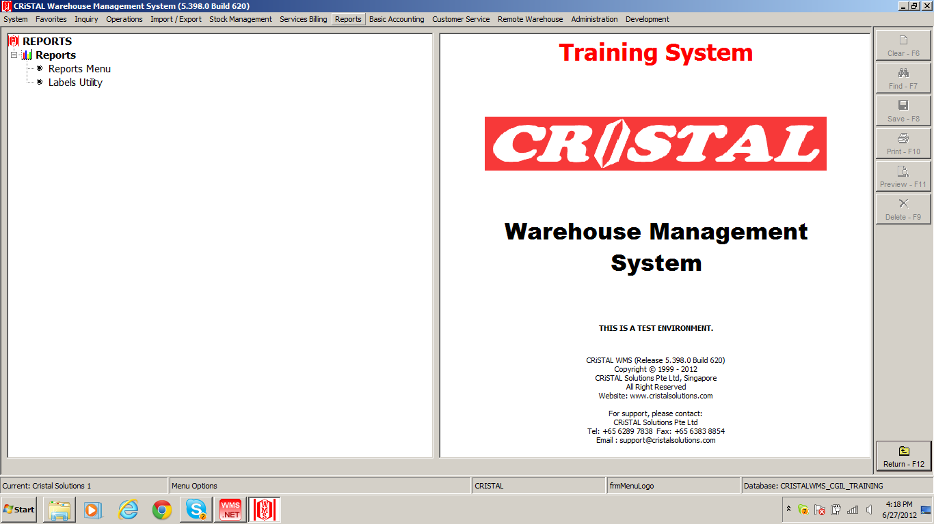

To view or print reports for inventories status, movements, storage, etc.

6 – Reports

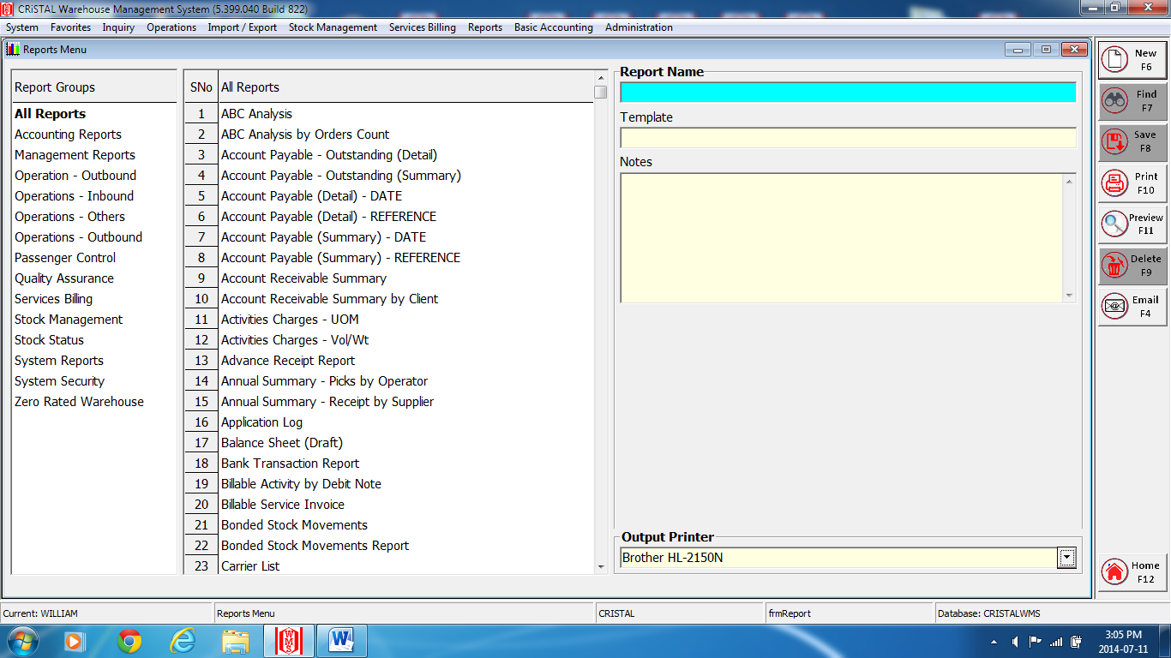
Fig.1
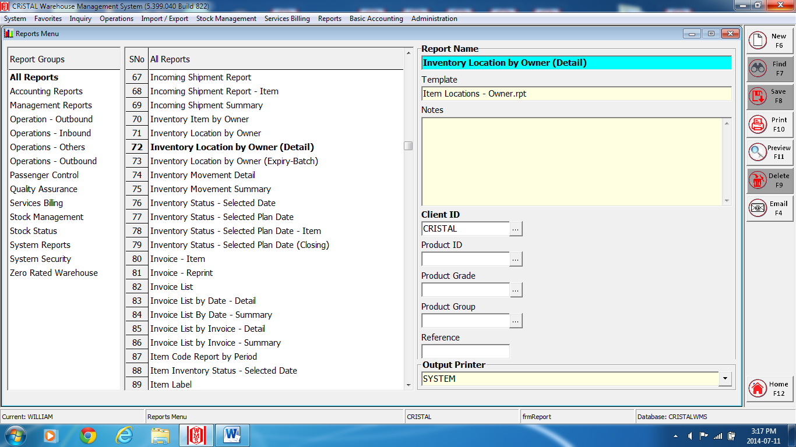
Fig.2

- Click on the Reports Menu to open a list of reports (Fig.1).
- Select and enter the require report (Fig.2)
- Enter the details require for that selected report.
All mandatory* fields must be enter.
- Enter ‘Preview’ or F11 to preview the report.
- Enter ‘Print’ or F10 to print
- Close and exit the page.

Report samples

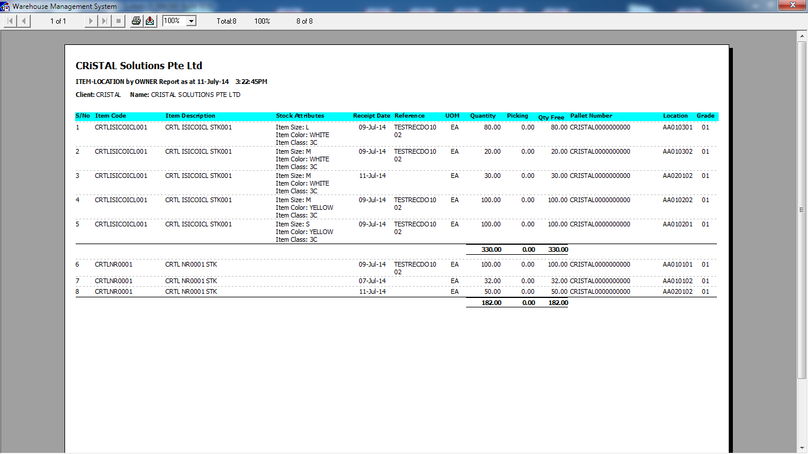

7 – Import / Export (WI Import)

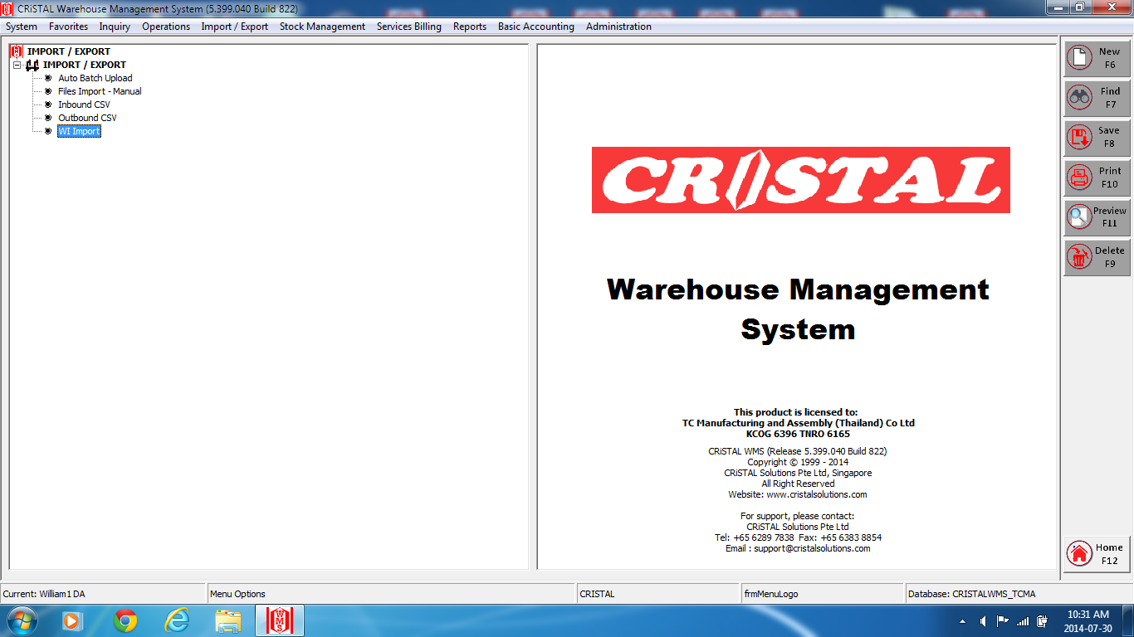

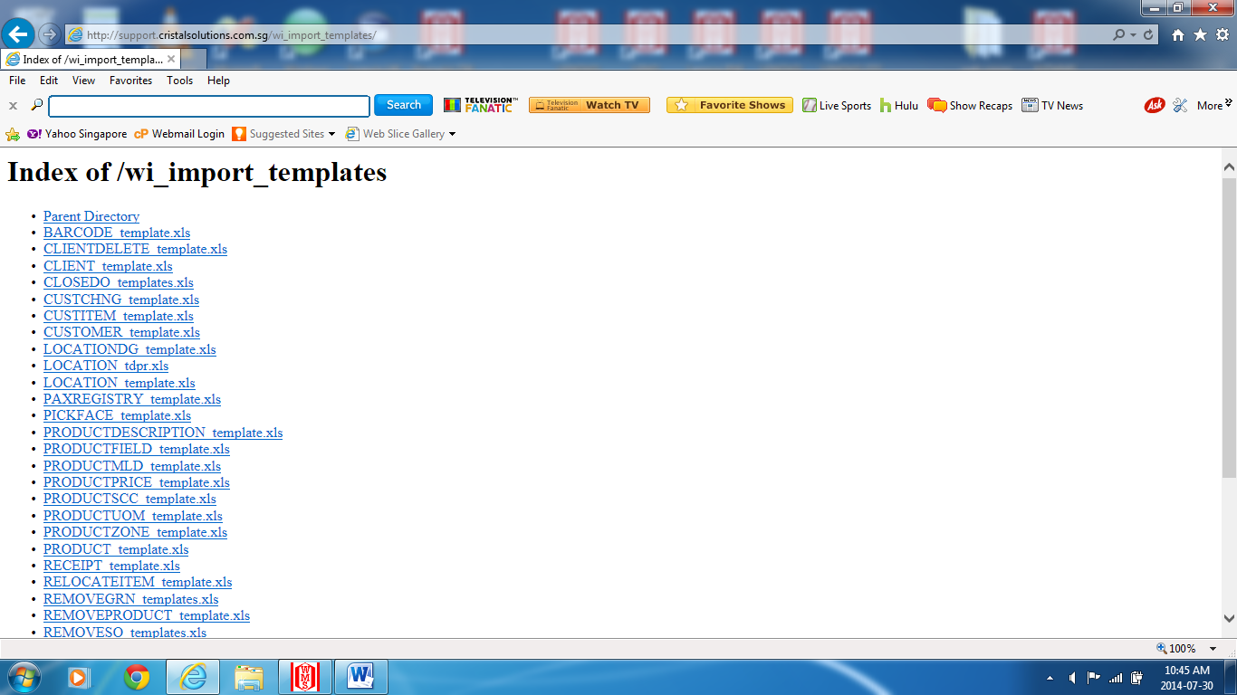
Fig.1

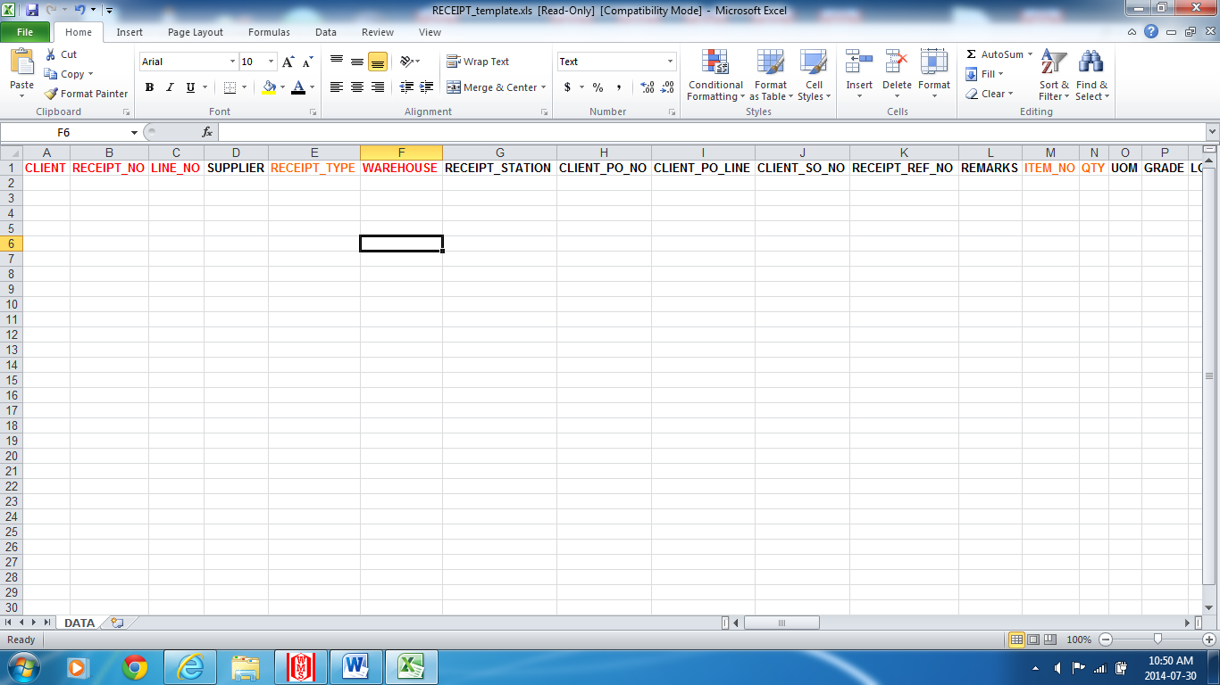
Fig.2

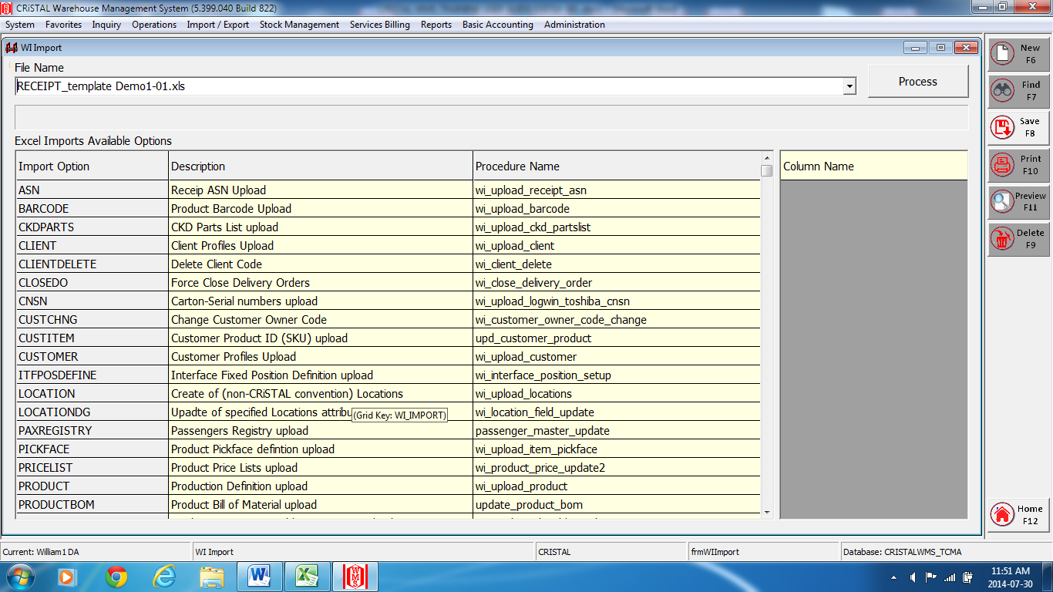
Fig. 3

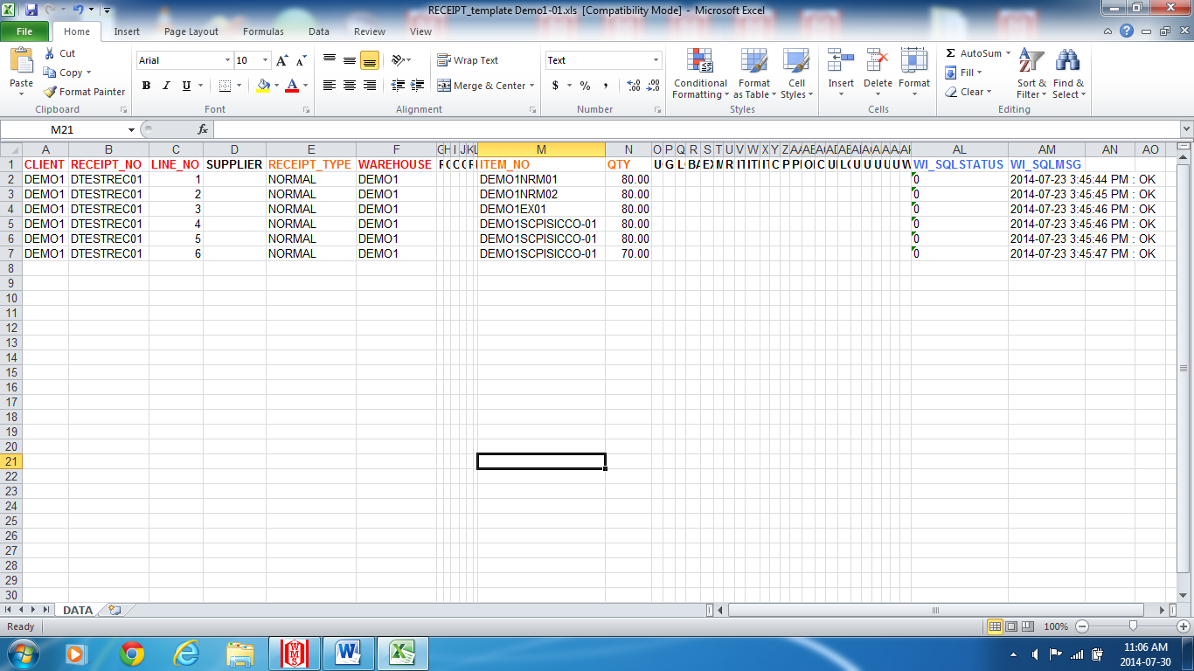
Fig. 4

WI Import

- Select and enter the require wi_ import_ template. (Fig.1).
- Enter data at the require fields. All highlighted* column fields are mandatory fields. (Fig.2)
- Save file as the named template follow by prefer name, eg. RECEIPT_ xxxxxx into desktop- Document.
4) At Import / Export menu – WI Import, click on the File Name drop down box to open the
saved wi _import template to import into system. Fig.3
5) Select and enter the require template file.
6) Click on the Process button to start importing data into system.
A message ‘Upload done. Please check spreadsheet for upload status.’
7) Open back the saved spreadsheet file for the import to check for status. (Fig. 4)
8) Close and exit the page.

